MBA680 · Behavioural Finance
Technical Analysis, Horizon Trading Strategies
and Behavioural Biases
Twelve indicators, three strategies and eight biases, implemented in TradingView Pine Script v6
and tested on seven NSE Top-100 stocks, January 2015 – September 2026
Submitted by
Adwaaiit Pande (230085)
Ayushi Mishra (230275)
Sample: RELIANCE · HDFCBANK · INFY · ITC · MARUTI · SUNPHARMA · LT (NSE, daily)
Deliverables: this report + 18 Pine Script v6 files (.pine) + Python replication code
October 2026
Contents
Executive Summary 3
1. Objective, Scope and Requirement Map 5
2. Data, Sample and Methodology 6
2.1 The seven stocks 6
2.2 Data source and quality checks 6
2.3 Pine Script implementation and Python replication 7
2.4 Backtest conventions (identical in Pine and Python) 7
3. Technical Indicators (Requirement 1) 8
3.1–3.12 The twelve indicators 8
3.13 Implementation on all seven stocks 16
4. Horizon Trading Strategies (Requirement 2) 18
4.1 Pine Script implementation 18
4.2 Results by strategy and stock 19
4.3 Interpretation 21
4.4 Example trades on TradingView-style charts 21
4.5 In-sample versus out-of-sample 22
4.6 Live validation on TradingView 22
5. Behavioural Biases: Impact and Illustration (Requirements 3 and 4) 24
5.1 Confirmation bias 24
5.2 Overconfidence 26
5.3 Anchoring bias 27
5.4 Representativeness bias 28
5.5 Recency bias 30
5.6 Conservatism bias 31
5.7 Herding 32
5.8 FOMO (fear of missing out) 33
6. Mitigating the Biases (Requirement 5) 35
6.1 Bias-by-bias mitigation and its Pine Script implementation 35
6.2 Testing the mitigations: chosen in-sample, judged out-of-sample 36
6.3 The out-of-sample verdict: subtraction beats addition 37
6.4 A pre-trade checklist enforced in code 37
6.5 Robustness: what would change our conclusions 38
7. Limitations 39
8. Conclusion and Recommendations 39
References 41
Appendix A. Pine Script File Inventory 43
Appendix B. Complete Pine Script Source 44
B.1–B.18 Source of all eighteen scripts 44

Executive Summary
We implemented twelve technical indicators (SMA, EMA, RSI, MACD, Bollinger Bands, Stochastic, ADX/DMI, OBV, Supertrend, CCI, MFI and Donchian Channel) and three horizon strategies (7-day mean reversion, 15-day momentum, 60-day trend following) in TradingView Pine Script v6, applied them to seven NSE Top-100 stocks drawn from seven different sectors, and used the same machinery to demonstrate, measure and mitigate eight behavioural biases. Every exhibit is backed by a Pine script that reproduces it on a live TradingView chart, and every number was independently replicated in Python on 2,904 daily sessions per stock (1 Jan 2015 – 25 Sep 2026).
Key findings
- No indicator has a statistically detectable edge. Pooled across the 7 stocks, none of the 12 canonical buy signals beats an average day at conventional significance: the best, the SMA 20/50 cross, adds 0.25 pp over 10 sessions (t = 0.78). The only significant results are negative: MFI crossing up through 20 (-1.00 pp, t = -2.19) and the Donchian 20-day breakout (-0.32 pp, t = -2.20) (Table 3.1).
- After realistic costs and a Treasury-bill return on idle cash, only the 60-day trend strategy earns its keep. At 0.15% per side and 6% a year on idle cash, Strategies A and B earn less than Treasury bills (excess Sharpe -0.02 and -0.24). Strategy C returns 7.9% a year with an excess Sharpe of 0.33, level with buy-and-hold's 0.32, at a 12% maximum drawdown against 40%. On unseen 2022–26 data, C beat buy-and-hold (Sharpe 0.42 vs 0.14; return 8.5% vs 7.1%; drawdown 7% vs 19%), although with 4.7 years of data the difference is within one standard error (±0.48).
- Overconfidence lies in treating an in-sample result as a forecast. The best of 25 Strategy A variants per stock promised an average Sharpe of 0.33 on 2015–21; on 2022–26 it delivered -0.02, and 6 of 7 stocks got worse. The untuned rule fell by a similar amount (0.12 to -0.35), so most of the fall is a change of regime after 2021, not overfitting alone. The bias is believing the in-sample number.
- Confirmation is an illusion of corroboration. The other eleven indicators correlate 0.64–0.95 with RSI, and CCI with Bollinger %B 0.98. Stacking redundant confirmations changed the RSI signal's hit rate by less than one point (all |z| < 0.2) while discarding up to 43% of the signals.
- The evidence differs in strength from bias to bias, and we grade it accordingly. Clear: confirmation, overconfidence, representativeness (no textbook pattern differed from its base rate) and anchoring, where holding losers to breakeven added 67 sessions and a 13.3% average interim loss, a risk cost that survivorship disguises as a return gain. Suggestive: herding (visible breakouts lag the average day; significant only for the Donchian breakout at 10 days, t = -2.20) and conservatism (one crash). Mixed: recency (chasing last quarter's winner lowered the Sharpe ratio on 4 of 7 stocks but raised return on 4). Not supported: FOMO (a 10-day delay cut Strategy C's average trade, but t = 0.63).
- The mitigation that survives out-of-sample is subtraction, not addition. Of six candidate rules chosen on 2015–21 data only, one was adopted (an ATR stop for Strategy B), and B stayed negative out-of-sample (Sharpe -0.88 to -0.69). Supertrend as a trailing exit was tested and rejected. The disciplined 21-sleeve portfolio scored -0.16 out-of-sample against 0.42 for Strategy C alone: the effective de-biasing step was to drop the rules that do not clear the cost-and-cash hurdle.

Recommendation. For a retail broker or robo-advisory platform, the evidence supports four defaults: steer rule-based users towards long horizons; show the all-in cost of a trade and the Treasury-bill hurdle before the order is placed; print the base rate beside any chart pattern; and show any optimised backtest only next to its out-of-sample record. Section 8 develops these.

How to read this report. Section 1 maps every assignment requirement to a section, a Pine file and an exhibit. Section 2 describes the data and backtest conventions. Section 3 covers the twelve indicators (requirement 1) and Section 4 the three horizon strategies (requirement 2). Section 5 discusses each of the eight biases and illustrates it with a Pine Script example and evidence from the seven stocks (requirements 3 and 4). Section 6 sets out mitigation, tests it out-of-sample and checks how robust the conclusions are to costs, the cash rate and sampling error (requirement 5). The complete source of all eighteen Pine scripts is reproduced in Appendix B.

1. Objective, Scope and Requirement Map
The objective is to implement a technical-analysis trading strategy on TradingView using Pine Script, and to examine how behavioural biases distort such strategies and how those distortions can be contained. Technical analysis is a natural laboratory for behavioural finance: its signals are visual, pattern-based and open to interpretation, which is exactly where heuristics such as confirmation, anchoring and representativeness operate (Lo, Mamaysky & Wang, 2000; Park & Irwin, 2007). The same chart can therefore be read rationally or through a bias, and Pine Script lets us make both readings explicit, testable rules.
Why it matters in India. SEBI's study of the equity derivatives segment found that 93% of about one crore individual F&O traders lost money between FY22 and FY24, an average loss of roughly ₹2 lakh each including costs (SEBI, 2024). Much of that trading is chart- and signal-driven. The question this project asks is therefore practical: do the tools fail, or does the way people use them fail?
This submission extends our preliminary single-stock pilot (Reliance) to the full requirement of seven NSE Top-100 stocks, rebuilds the strategy rules with trend and volume filters informed by the pilot, adds a formal in-sample / out-of-sample protocol, and replaces the pilot's descriptive bias discussion with a measured experiment for each bias.
Exhibit 0. Where each requirement is answered
# | Assignment requirement | Report section | Pine Script file(s) | Exhibits
1 | ≥ 8 technical indicators on ≥ 7 NSE Top-100 stocks (we use 12) | 3 | 01–12, 13 (12 × 7 dashboard) | 2–16
2 | Trading strategies for 7-, 15- and 60-day horizons | 4 | 14, 15, 16 | 17–21, Tables 4.1–4.6
3 | Discussion of 8 biases' impact on a TA strategy | 5.1–5.8 ('Impact') | — | —
4 | Illustrative examples of each bias | 5.1–5.8 ('Illustration') | 17 (Bias Lab, 8 modes) | 22–29
5 | Mitigation of each bias | 6 | 18 (Disciplined strategy), 17 | 30–31, Tables 6.1–6.4
— | Illustration in TradingView / Pine Script at each step | Throughout + App. B | All 18 files | —

2. Data, Sample and Methodology

2.1 The seven stocks
We chose one large, liquid NSE Top-100 constituent from each of seven sectors so that the indicators and strategies are tested across different price behaviours: a trending conglomerate (Reliance), a bank (HDFC Bank), an IT exporter (Infosys), a range-bound defensive (ITC), a cyclical (Maruti Suzuki), a pharma name with a deep 2015–18 drawdown (Sun Pharma) and a capital-goods compounder (L&T). Using different sectors matters: an indicator that 'works' only on one stock is more likely to be a sample artefact than a property of the indicator.
Table 2.1 Sample statistics, 1 Jan 2015 – 25 Sep 2026 (adjusted daily data)
Symbol | Company | Sector | Sessions | Close Jan-15 (₹) | Close Sep-26 (₹) | CAGR | Ann. vol | Max DD
RELIANCE | Reliance Industries | Oil, Gas & Conglomerate | 2904 | 199.7 | 1226.0 | 16.7% | 26.9% | -45.1%
HDFCBANK | HDFC Bank | Private Banking | 2904 | 238.0 | 735.6 | 10.1% | 22.3% | -41.1%
INFY | Infosys | IT Services | 2904 | 493.6 | 1000.2 | 6.2% | 26.9% | -50.7%
ITC | ITC | FMCG | 2904 | 231.5 | 269.0 | 1.3% | 24.4% | -57.0%
MARUTI | Maruti Suzuki | Automobiles | 2904 | 3340.8 | 12065.0 | 11.6% | 27.1% | -59.2%
SUNPHARMA | Sun Pharmaceutical | Pharmaceuticals | 2904 | 822.2 | 1852.2 | 7.2% | 28.1% | -72.2%
LT | Larsen & Toubro | Capital Goods / Infra | 2904 | 1002.0 | 3876.2 | 12.2% | 26.7% | -55.6%
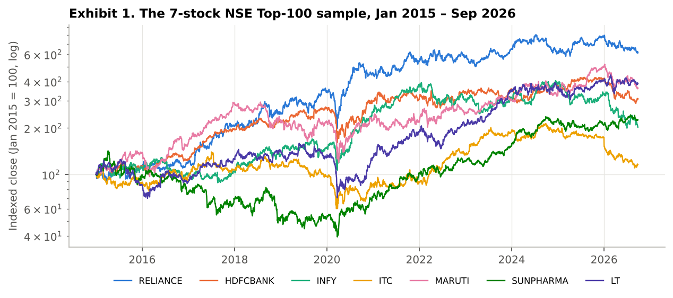
Exhibit 1. Indexed closing prices (log scale). The sample deliberately mixes strong compounders (Reliance, L&T, Maruti) with a near-flat stock (ITC) and a deep-drawdown stock (Sun Pharma).

2.2 Data source and quality checks
Daily open, high, low, close and volume for each stock were taken from the NSE end-of-day (bhavcopy) archive maintained in the public eod2_data GitHub repository, which stores prices adjusted for splits and bonuses but not for other corporate actions. We therefore screened every series for opening gaps above 5% and checked each against known corporate events. Three needed back-adjustment: Reliance's 1:15 rights issue (May 2020, factor 0.9906) and Jio Financial Services demerger (20 July 2023, factor 0.9079), and ITC's ITC Hotels demerger (6 January 2025, factor 0.9460). Prices before each ex-date are multiplied by the factor. The remaining large gaps are genuine market moves (e.g. the March 2020 crash, Infosys in October 2019, HDFC Bank in March 2026). We also checked for zero-volume sessions (none) and duplicate dates (none), and loaded 2014 only as a warm-up so that the 200-day average and 252-day high are fully formed on 1 January 2015, the first tradable day.
After these adjustments the data reproduce TradingView's own NSE series (dividend adjustment, 'ADJ', switched off): for example Reliance's opening prices on 12 Aug 2015, 6 Jan 2020, 26 Oct 2020 and 9 Nov 2021 are ₹216.65, ₹683.49, ₹954.13 and ₹1,137.11 here against ₹216.60, ₹683.50, ₹954.10 and ₹1,137.10 on TradingView. Without them, Reliance would show an artificial 9% one-day loss in July 2023 and ITC a 5% loss in January 2025, which would distort the indicators, the backtests and buy-and-hold returns.

2.3 Pine Script implementation and Python replication
Pine Script is the primary implementation: eighteen scripts (Appendix A) are written for Pine v6 and can be pasted into the TradingView Pine Editor and applied to any of the seven daily charts. Each indicator script uses TradingView's built-in functions (ta.sma, ta.ema, ta.rsi, ta.macd, ta.bb, ta.stoch, ta.dmi, ta.obv, ta.supertrend, ta.cci, ta.mfi, ta.highest/ta.lowest, ta.atr) and carries alertcondition() calls so it can drive live TradingView alerts.
Because TradingView evaluates one symbol per chart and cannot pool evidence across seven stocks or run 25-parameter grids in one pass, every result in this report was also computed in Python with formulas that replicate the Pine built-ins exactly (Wilder's RMA smoothing for RSI, ATR and ADX; population standard deviation for Bollinger Bands; signal on the bar's close and fill at the next bar's open). The charts are therefore produced from the replication rather than screenshots. The backtest engine was verified by hand: for a sample HDFC Bank trade the engine's entry/exit dates and prices match the signal bar and next-open convention exactly, and the final equity of every strategy equals the product of its trade returns to the paisa.

2.4 Backtest conventions (identical in Pine and Python)
Parameter | Setting | Why
Capital and sizing | ₹10,00,000; 100% of equity per trade; long-only; Pine margin_long = 0 | Isolates signal quality; no leverage, no shorting. margin_long = 0 stops TradingView rejecting or margin-calling a fully invested order when the next open gaps up
Positions | One at a time; new signals ignored while in a trade | Non-overlapping trades make the horizon well-defined
Entry timing | Signal on the close of bar t; fill at the open of t+1 | No look-ahead; TradingView's default order processing
Exit | Time exit after exactly 7 / 15 / 60 bars (filled at next open); optional ATR stop | Each strategy is defined by its horizon
Costs | 0.15% per side (base case); 0.05% and 0.25% tested in Section 6.5 | STT 0.1% on each side + stamp duty 0.015% on purchases + exchange, SEBI and GST charges ≈ 0.11%, plus about 0.03–0.04% slippage for a large cap; delivery brokerage is zero at discount brokers (Zerodha, 2026)
Idle cash | Earns 6% a year when not in a trade; 0% tested in Section 6.5 | Approximate 2015–26 average of the 91-day Treasury bill (range roughly 3.3–7.5%); a strategy that sits in cash must beat what that cash earns
Sharpe ratio | Annualised, on daily returns in excess of 6%; standard error from Lo (2002) | Excess-return Sharpe is the standard definition; the standard error shows which differences are within sampling noise
Period | 1 Jan 2015 – 25 Sep 2026; in-sample 2015–21, out-of-sample 2022–26 | Out-of-sample split is used for the overconfidence test and to select mitigations
Benchmark | Buy-and-hold of the same stock, same costs | The hurdle any timing strategy must clear
Horizons are measured in trading sessions: 7, 15 and 60 sessions correspond to roughly 1.5 weeks, 3 weeks and 3 calendar months.

3. Technical Indicators (Requirement 1)
We selected twelve indicators that span the five families used in practice, so that later sections can test whether combining indicators adds information or merely repeats it: trend (SMA, EMA, MACD, Supertrend), momentum / oscillators (RSI, Stochastic, CCI), volatility and channels (Bollinger Bands, Donchian Channel; ATR is also used for stops), trend strength (ADX/DMI) and volume (OBV, MFI). Every indicator uses its standard textbook parameters, identical on all seven stocks; nothing is tuned per stock, for the reasons set out in Section 5.2.
Exhibit 2. Indicator specification
# | Indicator | Family | Parameters | Canonical buy signal | Pine file
1 | SMA crossover | Trend | 20, 50 (+200) | SMA20 crosses above SMA50 | 01_SMA_Crossover
2 | EMA crossover | Trend | 9, 21 | EMA9 crosses above EMA21 | 02_EMA_Crossover
3 | RSI | Momentum | 14; 30/70 | RSI crosses up through 30 | 03_RSI
4 | MACD | Trend/momentum | 12, 26, 9 | MACD crosses above signal | 04_MACD
5 | Bollinger Bands | Volatility | 20, 2σ | Close crosses back above lower band | 05_Bollinger_Bands
6 | Stochastic | Momentum | 14, 3, 3 | %K crosses %D below 20 | 06_Stochastic
7 | ADX / DMI | Trend strength | 14, 14; 25 | +DI crosses −DI with ADX > 25 | 07_ADX_DMI
8 | OBV | Volume | EMA 20 | OBV crosses above its EMA | 08_OBV
9 | Supertrend | Trend / volatility | ATR 10, × 3 | Trend direction flips to up | 09_Supertrend
10 | CCI | Momentum | 20; ±100 | CCI crosses up through −100 | 10_CCI
11 | MFI | Volume-weighted momentum | 14; 20/80 | MFI crosses up through 20 | 11_MFI
12 | Donchian Channel | Channel / breakout | 20 | Close above prior 20-day high | 12_Donchian_Channel
Each indicator is illustrated below on one stock, so that between them the twelve exhibits cover all seven stocks; the 7-stock implementation is then shown for all twelve indicators together in Section 3.13.

3.1 Simple Moving Average (SMA 20/50, SMA 200)
The arithmetic mean of the last n closes. A 20-day average crossing above a 50-day average (golden cross) signals that recent prices are rising faster than the medium-term trend; the 200-day average marks the long-term regime. SMAs weight every day equally, so they are smooth but slow.
Formula: SMA(n)ₜ = (Cₜ + Cₜ₋₁ + … + Cₜ₋ₙ₊₁) / n
Pine Script core (full script: 01_SMA_Crossover.pine):
fast = ta.sma(close, 20)
slow = ta.sma(close, 50)
golden = ta.crossover(fast, slow)
bgcolor(close > ta.sma(close, 200) ? color.new(#008300, 94) : color.new(#e34948, 94))
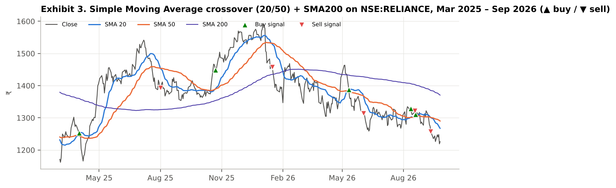
Exhibit 3. Simple Moving Average (SMA 20/50, SMA 200) on NSE:RELIANCE, Mar 2025 – Sep 2026. ▲ = buy signal, ▼ = sell signal, as plotted by 01_SMA_Crossover.pine.

3.2 Exponential Moving Average (EMA 9/21)
An average that weights recent closes more heavily (smoothing factor α = 2/(n+1)), so it turns faster than an SMA of similar length. The 9/21 pair is a common short-term trend filter; the fill between the two lines makes the regime visible at a glance.
Formula: EMAₜ = α·Cₜ + (1 − α)·EMAₜ₋₁, α = 2/(n+1)
Pine Script core (full script: 02_EMA_Crossover.pine):
f = ta.ema(close, 9)
s = ta.ema(close, 21)
fill(plot(f), plot(s), color = f > s ? color.new(#008300, 85) : color.new(#e34948, 85))
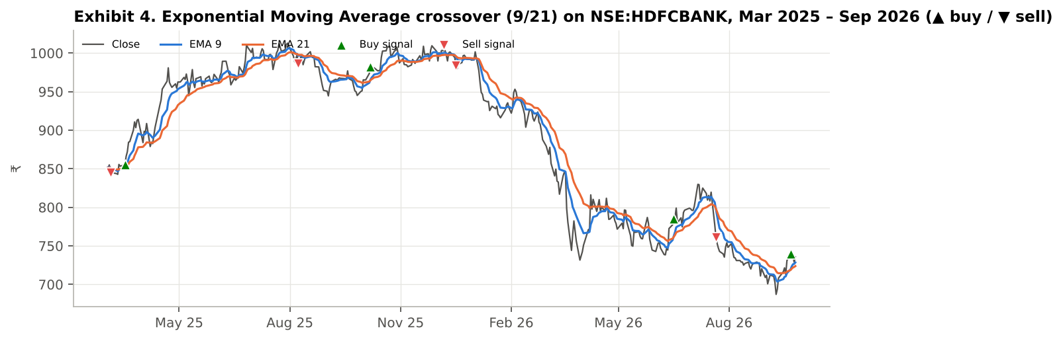
Exhibit 4. Exponential Moving Average (EMA 9/21) on NSE:HDFCBANK, Mar 2025 – Sep 2026. ▲ = buy signal, ▼ = sell signal, as plotted by 02_EMA_Crossover.pine.

3.3 Relative Strength Index (RSI 14)
Wilder's momentum oscillator: the ratio of average up-moves to average down-moves over 14 sessions, mapped to 0–100. Readings below 30 are conventionally 'oversold' and above 70 'overbought'; a cross back above 30 is the canonical buy signal.
Formula: RSI = 100 − 100 / (1 + RMA(gains,14) / RMA(losses,14))
Pine Script core (full script: 03_RSI.pine):
r = ta.rsi(close, 14)
buy = ta.crossover(r, 30)
sell = ta.crossunder(r, 70)
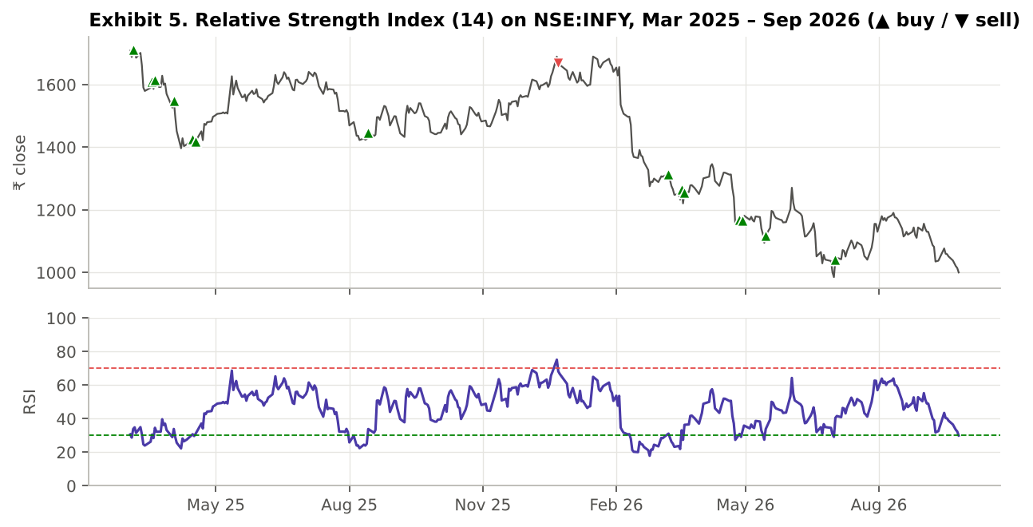
Exhibit 5. Relative Strength Index (RSI 14) on NSE:INFY, Mar 2025 – Sep 2026. ▲ = buy signal, ▼ = sell signal, as plotted by 03_RSI.pine.

3.4 Moving Average Convergence Divergence (MACD 12, 26, 9)
The difference between a 12- and a 26-period EMA (the MACD line), its 9-period EMA (the signal line), and their difference (the histogram). A MACD cross above its signal line marks accelerating momentum.
Formula: MACD = EMA₁₂ − EMA₂₆; Signal = EMA₉(MACD); Hist = MACD − Signal
Pine Script core (full script: 04_MACD.pine):
[m, sig, hist] = ta.macd(close, 12, 26, 9)
bull = ta.crossover(m, sig)
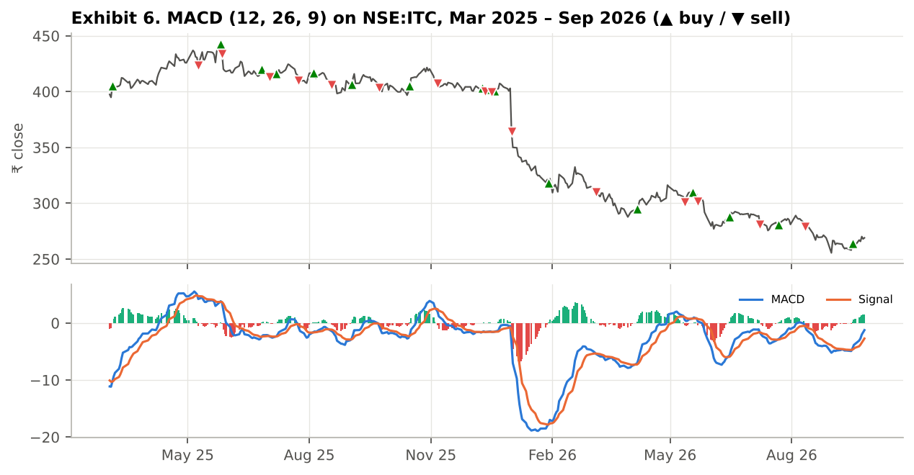
Exhibit 6. Moving Average Convergence Divergence (MACD 12, 26, 9) on NSE:ITC, Mar 2025 – Sep 2026. ▲ = buy signal, ▼ = sell signal, as plotted by 04_MACD.pine.

3.5 Bollinger Bands (20, 2σ)
A 20-day SMA with bands two standard deviations above and below. The bands widen with volatility; a close back inside the lower band is a mean-reversion buy signal, and an unusually narrow band (a 'squeeze', shaded) often precedes a volatility expansion. %B locates the close within the bands (0 = lower, 1 = upper).
Formula: Upper/Lower = SMA₂₀ ± 2·σ₂₀; %B = (C − Lower)/(Upper − Lower)
Pine Script core (full script: 05_Bollinger_Bands.pine):
[mid, up, lo] = ta.bb(close, 20, 2.0)
buy = ta.crossover(close, lo)
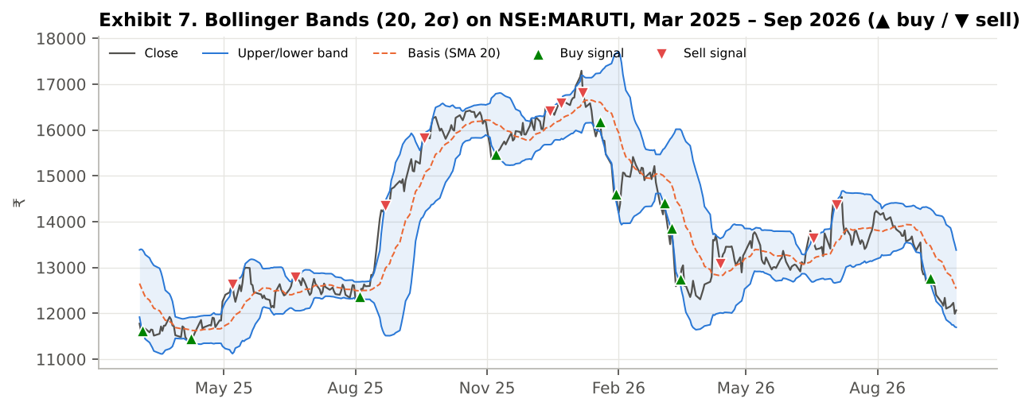
Exhibit 7. Bollinger Bands (20, 2σ) on NSE:MARUTI, Mar 2025 – Sep 2026. ▲ = buy signal, ▼ = sell signal, as plotted by 05_Bollinger_Bands.pine.

3.6 Stochastic Oscillator (14, 3, 3)
Locates the close within the 14-day high–low range (%K, smoothed over 3 days) with a 3-day signal line (%D). A %K cross above %D while below 20 is an oversold buy signal. It is faster and noisier than RSI.
Formula: %K = SMA₃(100·(C − L₁₄)/(H₁₄ − L₁₄)); %D = SMA₃(%K)
Pine Script core (full script: 06_Stochastic.pine):
k = ta.sma(ta.stoch(close, high, low, 14), 3)
d = ta.sma(k, 3)
buy = ta.crossover(k, d) and k < 20
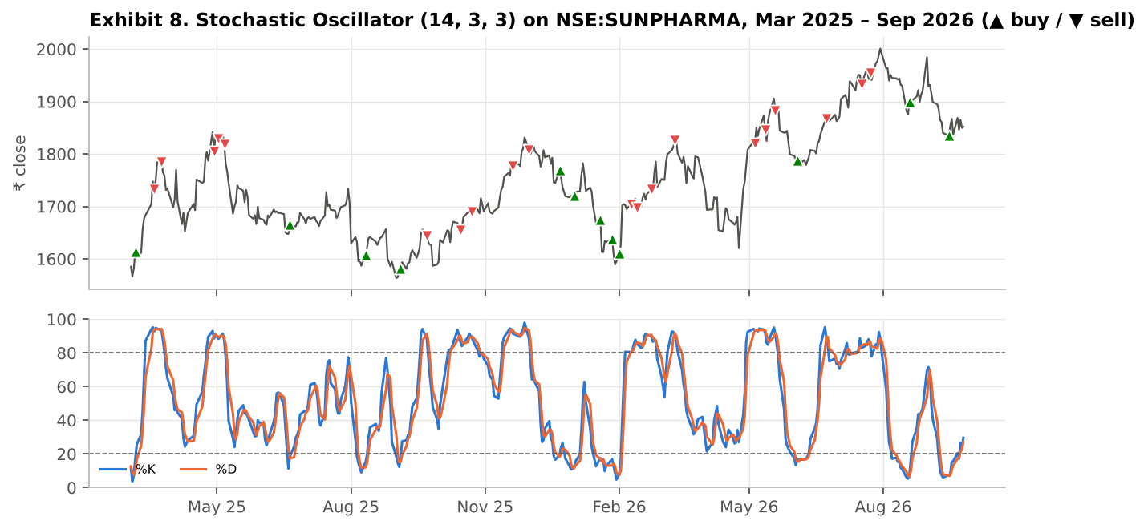
Exhibit 8. Stochastic Oscillator (14, 3, 3) on NSE:SUNPHARMA, Mar 2025 – Sep 2026. ▲ = buy signal, ▼ = sell signal, as plotted by 06_Stochastic.pine.

3.7 Average Directional Index with DMI (14)
Wilder's trend-strength measure. +DI and −DI measure upward and downward directional movement; ADX smooths their normalised difference. ADX above 20–25 indicates a trending market regardless of direction, and +DI above −DI gives the direction. It is used here as a filter, not a trigger.
Formula: DX = 100·|+DI − −DI| / (+DI + −DI); ADX = RMA₁₄(DX)
Pine Script core (full script: 07_ADX_DMI.pine):
[pdi, ndi, adx] = ta.dmi(14, 14)
trending = adx > 25
buy = ta.crossover(pdi, ndi) and adx > 20
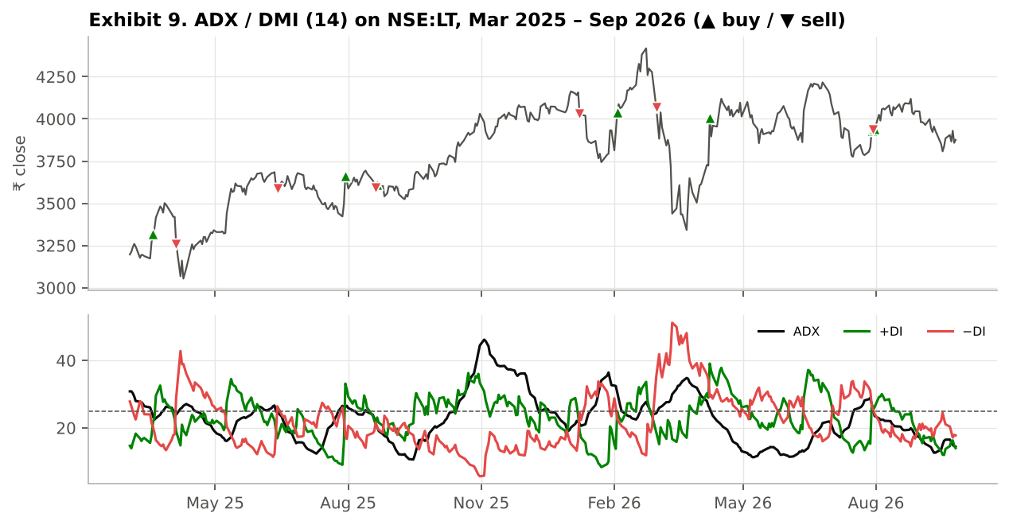
Exhibit 9. Average Directional Index with DMI (14) on NSE:LT, Mar 2025 – Sep 2026. ▲ = buy signal, ▼ = sell signal, as plotted by 07_ADX_DMI.pine.

3.8 On-Balance Volume (OBV) with EMA 20
A running total that adds the day's volume when the close rises and subtracts it when the close falls. OBV crossing above its 20-day EMA signals accumulation; a new price high without a new OBV high (shaded) is a bearish divergence. Together with MFI (3.11) it is one of only two indicators in the set that use volume, which matters for the confirmation-bias test in Section 5.1.
Formula: OBVₜ = OBVₜ₋₁ + sign(Cₜ − Cₜ₋₁)·Vₜ
Pine Script core (full script: 08_OBV.pine):
obv = ta.obv
sig = ta.ema(obv, 20)
bull = ta.crossover(obv, sig)
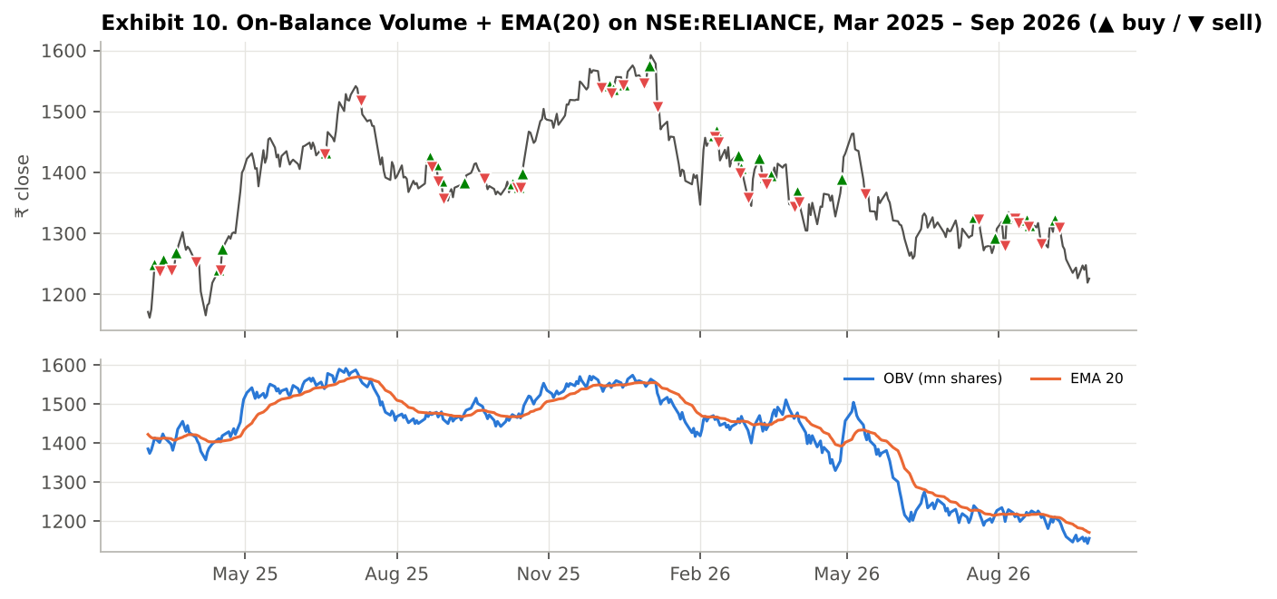
Exhibit 10. On-Balance Volume (OBV) with EMA 20 on NSE:RELIANCE, Mar 2025 – Sep 2026. ▲ = buy signal, ▼ = sell signal, as plotted by 08_OBV.pine.

3.9 Supertrend (ATR 10, multiplier 3)
An ATR-based trailing line. It sits 3 × ATR below the mid-price (hl2) in an up-trend and 3 × ATR above it in a down-trend, ratcheting only in the trend's direction; a close through the line flips the trend. Because the band width scales with volatility, it gives a volatility-adjusted trend state and a ready-made trailing stop.
Formula: Lower band = hl2 − 3·ATR₁₀ (ratchets up only); Upper band = hl2 + 3·ATR₁₀ (ratchets down only)
Pine Script core (full script: 09_Supertrend.pine):
[st, dir] = ta.supertrend(3.0, 10) // dir = -1 up-trend
buy = ta.change(dir) < 0
sell = ta.change(dir) > 0
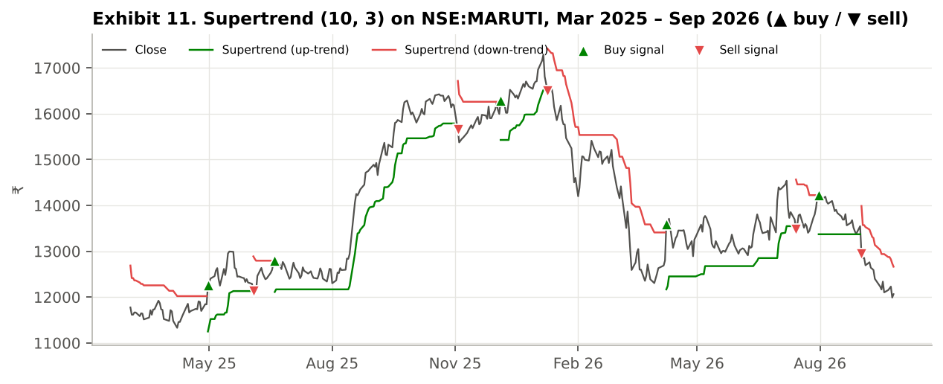
Exhibit 11. Supertrend (ATR 10, multiplier 3) on NSE:MARUTI, Mar 2025 – Sep 2026. ▲ = buy signal, ▼ = sell signal, as plotted by 09_Supertrend.pine.

3.10 Commodity Channel Index (CCI 20)
Lambert's oscillator measures how far the typical price (H+L+C)/3 is from its 20-day average, in units of its mean absolute deviation scaled by 0.015 so that most readings fall between −100 and +100. A cross back above −100 is the canonical oversold buy signal. It is unbounded, which makes extreme readings stand out.
Formula: CCI = (TP − SMA₂₀(TP)) / (0.015 · MeanDev₂₀(TP)), TP = (H + L + C)/3
Pine Script core (full script: 10_CCI.pine):
cci = ta.cci(hlc3, 20)
buy = ta.crossover(cci, -100)
sell = ta.crossunder(cci, 100)
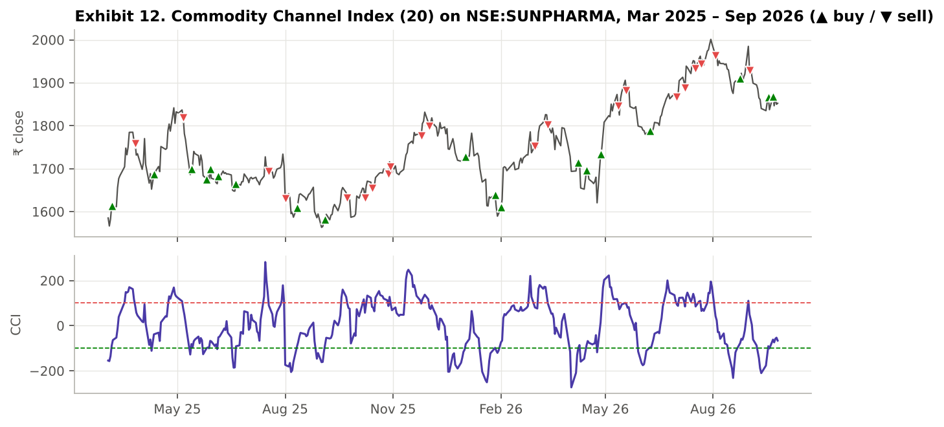
Exhibit 12. Commodity Channel Index (CCI 20) on NSE:SUNPHARMA, Mar 2025 – Sep 2026. ▲ = buy signal, ▼ = sell signal, as plotted by 10_CCI.pine.

3.11 Money Flow Index (MFI 14)
A volume-weighted RSI: money flow (typical price × volume) on up-days is compared with money flow on down-days over 14 sessions and mapped to 0–100. Readings below 20 are oversold and above 80 overbought. Because it uses volume, it can diverge from RSI when a move is not supported by turnover (shaded in the script).
Formula: MFI = 100 − 100 / (1 + Σ₁₄ positive money flow / Σ₁₄ negative money flow)
Pine Script core (full script: 11_MFI.pine):
mfi = ta.mfi(hlc3, 14)
buy = ta.crossover(mfi, 20)
sell = ta.crossunder(mfi, 80)
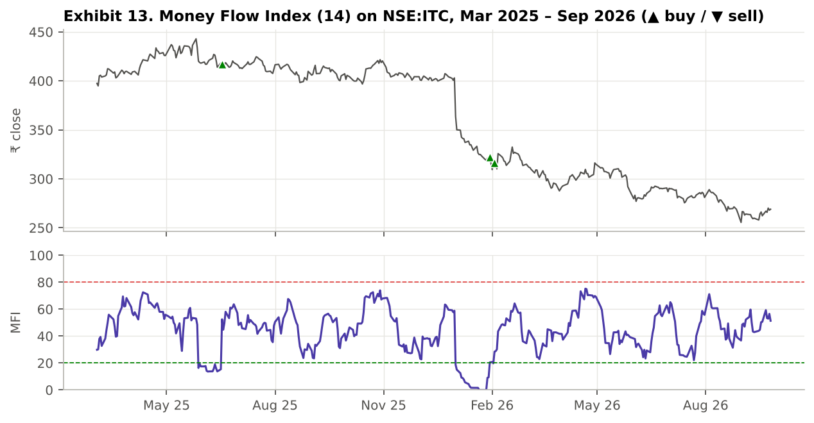
Exhibit 13. Money Flow Index (MFI 14) on NSE:ITC, Mar 2025 – Sep 2026. ▲ = buy signal, ▼ = sell signal, as plotted by 11_MFI.pine.

3.12 Donchian Channel (20)
The highest high and lowest low of the last 20 sessions, with their mid-point. A close above the prior 20-day high is the classic 'Turtle' breakout entry; a close below the prior 20-day low is the breakdown. It is the most visible breakout rule on any chart, which makes it the natural test case for herding (Section 5.7).
Formula: Upper = max(H, 20); Lower = min(L, 20); Mid = (Upper + Lower)/2
Pine Script core (full script: 12_Donchian_Channel.pine):
up = ta.highest(high, 20)
lo = ta.lowest(low, 20)
buy = ta.crossover(close, up[1])
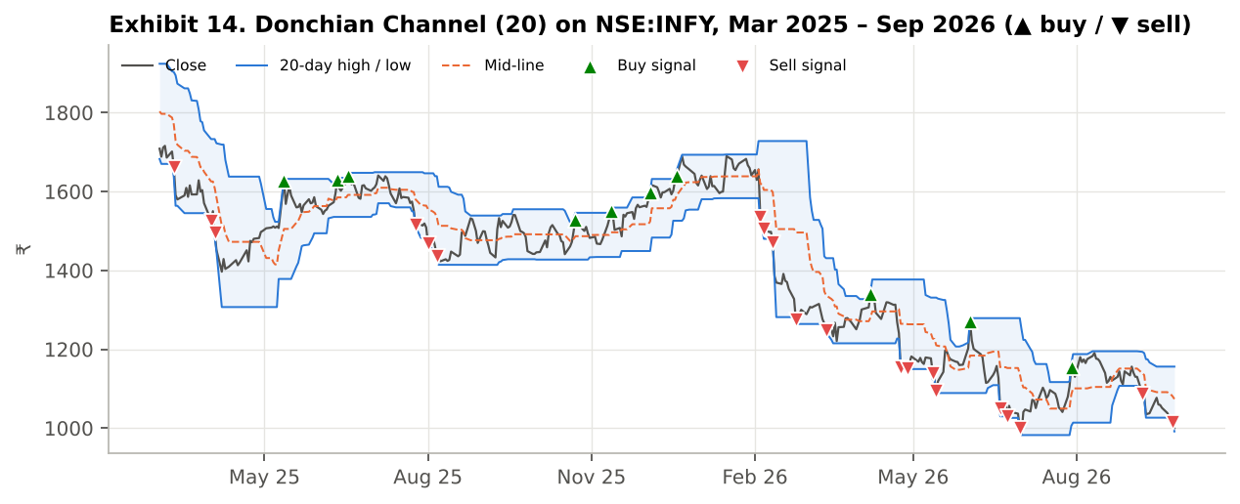
Exhibit 14. Donchian Channel (20) on NSE:INFY, Mar 2025 – Sep 2026. ▲ = buy signal, ▼ = sell signal, as plotted by 12_Donchian_Channel.pine.

3.13 Implementation on all seven stocks
Requirement 1 asks for each indicator to be implemented on at least seven stocks. We do this in two ways. First, all twelve indicator scripts are symbol-agnostic and were applied to each of the seven daily charts. Second, a single dashboard script (13_SevenStock_Dashboard.pine) uses request.security() to compute all twelve indicators for all seven stocks at once (seven calls, each returning a 14-value tuple) and print their state in a table on any chart. Exhibit 16 reproduces that table as at the last bar of our sample.
Exhibit 16. 12 × 7 indicator dashboard as at 2026-09-25 (▲ bullish state, ▼ bearish state; as rendered by 13_SevenStock_Dashboard.pine)
Stock | SMA | EMA | RSI | MACD | BB | Stoch | ADX | OBV | SupT | CCI | MFI | Donch | Score
RELIANCE | ▼ | ▼ | ▼ | ▼ | ▼ | ▼ | ▼ | ▼ | ▼ | ▼ | ▼ | ▼ | 0/12
HDFCBANK | ▼ | ▲ | ▲ | ▲ | ▲ | ▼ | ▲ | ▲ | ▲ | ▲ | ▲ | ▲ | 10/12
INFY | ▼ | ▼ | ▼ | ▼ | ▼ | ▼ | ▼ | ▼ | ▼ | ▼ | ▼ | ▼ | 0/12
ITC | ▼ | ▼ | ▲ | ▲ | ▲ | ▲ | ▼ | ▼ | ▼ | ▲ | ▲ | ▲ | 7/12
MARUTI | ▼ | ▼ | ▼ | ▼ | ▼ | ▼ | ▼ | ▼ | ▼ | ▼ | ▼ | ▼ | 0/12
SUNPHARMA | ▼ | ▼ | ▼ | ▼ | ▼ | ▲ | ▼ | ▼ | ▼ | ▼ | ▼ | ▼ | 1/12
LT | ▼ | ▼ | ▼ | ▼ | ▼ | ▼ | ▼ | ▼ | ▼ | ▼ | ▼ | ▼ | 0/12
The snapshot shows how the twelve indicators summarise market state: on 2026-09-25 HDFC Bank scored 10/12 bullish and ITC 7/12, while Reliance, Infosys, Maruti and L&T scored 0/12 and Sun Pharma 1/12, with Maruti's ADX of 49 indicating a strong down-trend and Infosys and Maruti sitting on RSI ≈ 30. It also illustrates the redundancy discussed in Section 5.1: the twelve 'votes' almost always agree, because ten of them are computed from price alone and only OBV and MFI bring in volume. The four added indicators voted with the existing majority wherever there was one (all four bullish on HDFC Bank, all four bearish on the five bearish stocks), and on ITC, previously split 4/8, three of the four sided with the bulls. More indicators made each verdict look more certain without adding independent evidence.
Exhibit 15 then tests every indicator's canonical buy signal on every stock: the cell shows the average 10-session forward return after the signal minus the stock's unconditional 10-session return, with the number of signals underneath. Table 3.1 pools the seven stocks.
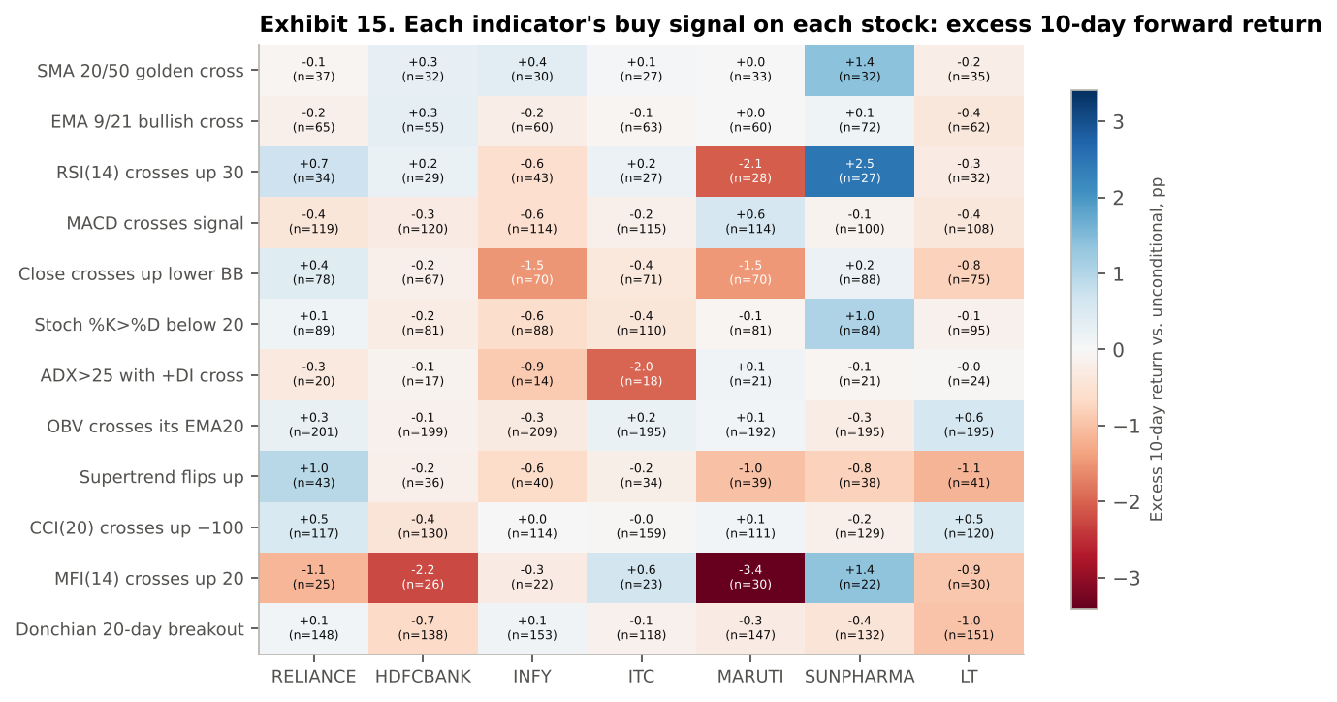
Exhibit 15. Excess 10-session forward return (percentage points) after each indicator's buy signal, by stock; n = number of signals, Jan 2015 – Sep 2026. Forward returns are measured from the next open, i.e. as tradeable.
Table 3.1 Canonical buy signals, 7 stocks pooled: 10-session forward return against the same stock's average day
Signal | n | Avg 10-day | Hit rate | Excess (pp) | 95% CI (pp) | t
SMA 20/50 golden cross | 226 | 0.75% | 57.5% | 0.25 | -0.37 to 0.87 | 0.78
EMA 9/21 bullish cross | 437 | 0.44% | 54.0% | -0.05 | -0.53 to 0.43 | -0.21
RSI(14) crosses up 30 | 220 | 0.55% | 58.2% | 0.05 | -0.89 to 0.99 | 0.11
MACD crosses signal | 790 | 0.29% | 51.0% | -0.20 | -0.54 to 0.15 | -1.12
Close crosses up lower BB | 519 | 0.01% | 50.1% | -0.49 | -1.05 to 0.08 | -1.69
Stoch %K>%D below 20 | 628 | 0.42% | 53.2% | -0.06 | -0.50 to 0.39 | -0.26
ADX>25 with +DI cross | 135 | 0.08% | 53.3% | -0.43 | -1.21 to 0.35 | -1.07
OBV crosses its EMA20 | 1386 | 0.56% | 53.8% | 0.07 | -0.19 to 0.32 | 0.50
Supertrend flips up | 271 | 0.08% | 50.9% | -0.42 | -1.00 to 0.17 | -1.40
CCI(20) crosses up −100 | 880 | 0.54% | 54.1% | 0.06 | -0.29 to 0.41 | 0.35
MFI(14) crosses up 20 | 178 | -0.50% | 48.3% | -1.00 | -1.89 to -0.11 | -2.19
Donchian 20-day breakout | 987 | 0.18% | 52.8% | -0.32 | -0.61 to -0.04 | -2.20
Unconditional (any day) | — | 0.49% | 54.3% | — | — | —
Excess = signal's average 10-session return minus that stock's average 10-session return. t > 1.96 in absolute value means significant at 5% (shaded). Signals on the same stock a few days apart overlap, so these standard errors, if anything, flatter significance.
Reading. No indicator on its own beats simply being invested by more than sampling noise. The best pooled signal, the SMA 20/50 golden cross, adds 0.25 pp over 10 days with a 95% confidence interval of -0.37 to 0.87 pp; every positive signal has |t| below 1. If no indicator had any edge, about half of the 12 would still land above the average day by chance, and 4 did. The only statistically significant results are negative: MFI crossing up through 20 (t = -2.19) and the Donchian 20-day breakout (t = -2.20), which we return to under herding (Section 5.7). The four indicators added to the original eight therefore broadened the toolkit but added no edge. The cell-level picture in Exhibit 15 is also unstable: the RSI signal adds +2.5 pp on Sun Pharma but -2.1 pp on Maruti. This instability is the raw material for several of the biases in Section 5: an analyst who looks only at the Sun Pharma column will 'see' a powerful RSI edge (confirmation and representativeness), and one who has just watched it work will over-weight it (recency).

4. Horizon Trading Strategies (Requirement 2)
A trading horizon dictates which indicators are appropriate. Over 7 sessions, prices are dominated by short-term noise and over-reaction, so the natural edge is mean reversion. Over 15 sessions, the relevant effect is short-term momentum (continuation of a fresh move). Over 60 sessions, the relevant effect is the persistence of trends documented in the time-series momentum literature (Moskowitz, Ooi & Pedersen, 2012). Each strategy therefore pairs a trigger from one indicator family with filters from other families, and exits on a fixed time stop equal to its horizon. The pilot submission showed that unfiltered oscillator signals bought falling stocks; the 200-day trend filter in Strategy A and the OBV volume filter in Strategy B are the two design changes made in response.
Why the four added indicators are not in the strategy rules. Supertrend, CCI, MFI and Donchian are used for the indicator tests (Section 3.13) and the bias experiments (Sections 5.1, 5.6 and 5.7), and as a candidate trailing exit in the mitigation tests (Section 6.2), but deliberately not added to the entry rules of Strategies A–C. None of their buy signals beat an average day on pooled data (Table 3.1), and CCI and the Donchian position correlate 0.98 and 0.94 with Bollinger %B, so adding them would be the "indicator shopping" that Section 5.1 shows to be confirmation bias. Keeping the rules fixed also keeps them identical to the versions validated live on TradingView (Section 4.6).
Table 4.1 Strategy rules (all long-only, one position at a time, time exit at the horizon)
 | Strategy A — 7-day | Strategy B — 15-day | Strategy C — 60-day
Edge targeted | Short-term over-reaction (mean reversion) | Fresh momentum (continuation) | Established trend (persistence)
Trigger | RSI(14) crosses up 35, or Stoch %K crosses %D below 20 | MACD crosses above its signal line | SMA20 crosses above SMA50, or close crosses above SMA50
Filters | Close > SMA200 (buy dips only in up-trends) | EMA9 > EMA21 (trend) and OBV > EMA20 of OBV (volume) | SMA50 > SMA200, ADX > 20, +DI > −DI
Indicators used | RSI, Stochastic, SMA | MACD, EMA, OBV | SMA, ADX/DMI
Exit | Open of session 8 (7 sessions held) | Open of session 16 | Open of session 61
Pine file | 14_Strategy_A_7Day_MeanReversion | 15_Strategy_B_15Day_Momentum | 16_Strategy_C_60Day_Trend

4.1 Pine Script implementation
All three strategies share one template; only the entry rule and holding period change. The full Strategy B script is shown below (A and C are in Appendix B). The time exit uses strategy.opentrades.entry_bar_index(0) to count bars in the trade, and the entry is gated on strategy.position_size == 0 so trades never overlap.
//@version=6
// MBA680 | Strategy B — 15-day MACD/EMA momentum
// Long-only, one position at a time, 100% of equity, Rs 10 lakh, 0.15% commission per side (STT 0.1% + stamp/exchange/GST + slippage; set 0.05 to reproduce the validation run).
// Signal evaluated on the bar's close; orders fill at the NEXT bar's open (TradingView default).
// Exit: fixed holding period of `hold` bars (time stop). Optional ATR stop (off by default).
strategy("MBA680 · Strategy B — 15-day MACD/EMA momentum", overlay=true, initial_capital=1000000, currency=currency.INR,
default_qty_type=strategy.percent_of_equity, default_qty_value=100,
commission_type=strategy.commission.percent, commission_value=0.15, pyramiding=0,
margin_long=0, margin_short=0) // no margin checks: entries are never rejected or margin-called
hold = input.int(15, "Holding period (bars)", minval=1)
useStop = input.bool(false, "Use ATR stop")
stopMul = input.float(3.0, "ATR stop multiple", step=0.5)
tStart = input.time(timestamp("2015-01-01"), "Backtest start")
tEnd = input.time(timestamp("2026-12-31"), "Backtest end")
inWin = time >= tStart and time <= tEnd

// ---- indicators used ----
rsi = ta.rsi(close, 14)
k = ta.sma(ta.stoch(close, high, low, 14), 3)
d = ta.sma(k, 3)
[macd, sig, hist] = ta.macd(close, 12, 26, 9)
ema9 = ta.ema(close, 9)
ema21 = ta.ema(close, 21)
sma20 = ta.sma(close, 20)
sma50 = ta.sma(close, 50)
sma200 = ta.sma(close, 200)
[pdi, ndi, adx] = ta.dmi(14, 14)
obv = ta.obv
obvE = ta.ema(obv, 20)
atr = ta.atr(14)

// ---- entry rule ----
// Fresh MACD momentum, confirmed by short-term trend (EMA 9>21) and volume (OBV above its EMA)
longCond = ta.crossover(macd, sig) and ema9 > ema21 and obv > obvE

if longCond and inWin and strategy.position_size == 0
strategy.entry("Long", strategy.long)
if useStop
strategy.exit("Stop", "Long", stop = close - stopMul * atr)

// ---- time exit: close on the bar that completes `hold` bars in the trade ----
if strategy.position_size > 0 and bar_index - strategy.opentrades.entry_bar_index(0) >= hold - 1
strategy.close("Long", comment="Time exit")
if not inWin and strategy.position_size > 0
strategy.close("Long", comment="Window end")

plot(ema9, "EMA 9", color=#2a78d6)
plot(ema21, "EMA 21", color=#eb6834)
plotshape(longCond and strategy.position_size == 0, "Signal", shape.triangleup, location.belowbar, #008300, size=size.small)
bgcolor(strategy.position_size > 0 ? color.new(#2a78d6, 92) : na, title="In trade")
alertcondition(longCond, "Entry signal", "{{ticker}}: Strategy B — 15-day MACD/EMA momentum entry signal")

4.2 Results by strategy and stock
Table 4.2 Strategy A — 7-day mean reversion
Stock | Trades | Win % | Avg trade | Profit factor | CAGR | B&H CAGR | Max DD | Excess Sharpe | Time in mkt
RELIANCE | 40 | 43% | -0.38% | 0.78 | 3.8% | 16.7% | -20% | -0.23 | 10%
HDFCBANK | 32 | 38% | -0.83% | 0.38 | 3.1% | 10.1% | -13% | -0.52 | 8%
INFY | 27 | 70% | 0.77% | 1.61 | 7.3% | 6.2% | -13% | 0.21 | 7%
ITC | 28 | 46% | 0.07% | 1.06 | 5.7% | 1.3% | -9% | -0.04 | 7%
MARUTI | 37 | 51% | 0.22% | 1.15 | 6.0% | 11.6% | -16% | 0.02 | 9%
SUNPHARMA | 34 | 65% | 1.45% | 2.37 | 9.7% | 7.2% | -11% | 0.50 | 8%
LT | 36 | 44% | -0.26% | 0.81 | 4.6% | 12.2% | -14% | -0.21 | 9%
7-stock (EW) | 234 | 50% | 0.12% | 1.09 | 6.0% | 10.3% | -4% | -0.02 | 8%
Table 4.3 Strategy B — 15-day momentum
Stock | Trades | Win % | Avg trade | Profit factor | CAGR | B&H CAGR | Max DD | Excess Sharpe | Time in mkt
RELIANCE | 37 | 51% | 1.02% | 1.42 | 7.4% | 16.7% | -19% | 0.17 | 19%
HDFCBANK | 46 | 54% | 1.03% | 2.04 | 8.5% | 10.1% | -12% | 0.31 | 24%
INFY | 42 | 60% | -0.82% | 0.68 | 0.9% | 6.2% | -29% | -0.38 | 22%
ITC | 33 | 30% | -2.31% | 0.32 | -2.1% | 1.3% | -40% | -0.75 | 17%
MARUTI | 40 | 63% | 0.59% | 1.28 | 6.2% | 11.6% | -28% | 0.07 | 21%
SUNPHARMA | 36 | 44% | -1.65% | 0.54 | -1.1% | 7.2% | -40% | -0.53 | 19%
LT | 36 | 58% | 1.06% | 1.67 | 8.0% | 12.2% | -17% | 0.23 | 19%
7-stock (EW) | 270 | 52% | -0.08% | 0.96 | 4.8% | 10.3% | -7% | -0.24 | 20%
Table 4.4 Strategy C — 60-day trend following
Stock | Trades | Win % | Avg trade | Profit factor | CAGR | B&H CAGR | Max DD | Excess Sharpe | Time in mkt
RELIANCE | 19 | 63% | 5.59% | 3.23 | 12.0% | 16.7% | -21% | 0.43 | 39%
HDFCBANK | 13 | 77% | 4.71% | 7.74 | 9.6% | 10.1% | -25% | 0.37 | 27%
INFY | 7 | 57% | 0.13% | 1.03 | 4.8% | 6.2% | -27% | -0.08 | 14%
ITC | 5 | 40% | 1.51% | 1.35 | 5.8% | 1.3% | -23% | 0.01 | 10%
MARUTI | 9 | 56% | 2.81% | 2.43 | 6.9% | 11.6% | -24% | 0.13 | 19%
SUNPHARMA | 12 | 67% | 2.34% | 2.07 | 6.8% | 7.2% | -34% | 0.12 | 23%
LT | 15 | 53% | 2.96% | 1.98 | 7.5% | 12.2% | -24% | 0.17 | 30%
7-stock (EW) | 80 | 61% | 3.42% | 2.39 | 7.9% | 10.3% | -12% | 0.33 | 23%
All figures net of 0.15% per side, with idle cash earning 6% a year; CAGR therefore includes interest on cash, and Sharpe is measured on returns above 6%. Max DD and Sharpe for the 7-stock row are for the equal-weighted portfolio of the seven equity curves; B&H CAGR in that row is the equal-weighted buy-and-hold. Time in market is the average across stocks.
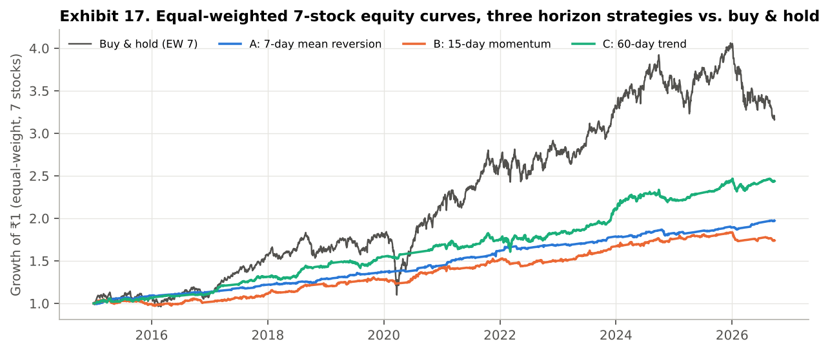
Exhibit 17. Equal-weighted 7-stock equity curves (growth of ₹1). Buy-and-hold dominates on terminal wealth; the strategies are flatter but suffer far smaller drawdowns, including through March 2020.
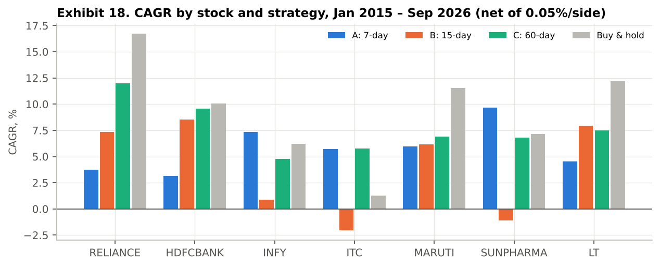
Exhibit 18. CAGR by stock and strategy, including interest on idle cash. Strategy C beats the Treasury-bill rate on 5 of 7 stocks; Strategy B loses money outright on 2.

4.3 Interpretation
Per-trade quality rises with horizon. Strategy C has the best average trade (3.42%), win rate (61%) and profit factor (2.39), followed by A (0.12%, PF 1.09) and B (-0.08%, PF 0.96). This ordering fits the evidence that trend persistence over months is a more robust effect in equities than 2–3 week momentum, which is crowded and noisy.
Only Strategy C clears the cash hurdle. Because idle capital earns the Treasury-bill rate, the right question is whether time in the market adds anything over cash. For Strategies A and B it does not: their excess Sharpe ratios are -0.02 and -0.24, so an investor would have done better holding Treasury bills. Strategy C returns 7.9% a year with an excess Sharpe of 0.33, level with equal-weighted buy-and-hold (0.32), at a 12% maximum drawdown against 40%. The two Sharpe ratios are statistically indistinguishable (standard error ±0.30); C's contribution is the same risk-adjusted return with about a third of the worst loss. Costs matter in proportion to turnover: at 0.05% per side A and B look respectable (Sharpe 0.35 and 0.18 with no cash return), but at realistic Indian delivery costs their thin per-trade edges disappear, while C, with 80 trades in twelve years, barely notices (Section 6.5).
Stock dependence is large. Strategy B has a positive excess Sharpe on 4 of 7 stocks and is strongly negative on ITC (-0.75) and Sun Pharma (-0.53); Strategy A's best stock, Sun Pharma (0.50), is B's second-worst. A strategy judged on one stock, or on the best stock, would be badly mis-estimated. This is the central behavioural point of the next section: the data are noisy enough to support almost any story an analyst is inclined to tell.

4.4 Example trades on TradingView-style charts
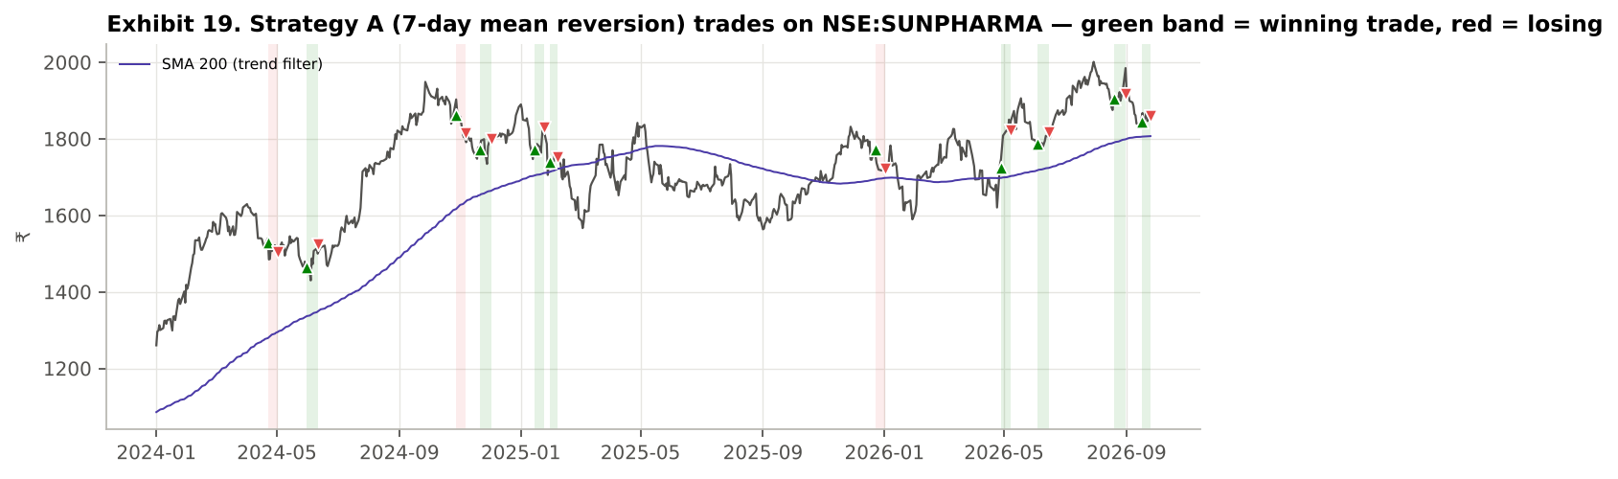
Exhibit 19. Strategy A on NSE:SUNPHARMA since Jan 2024: 11 trades, 73% winners. Entries are allowed only while the close is above the 200-day average (purple).
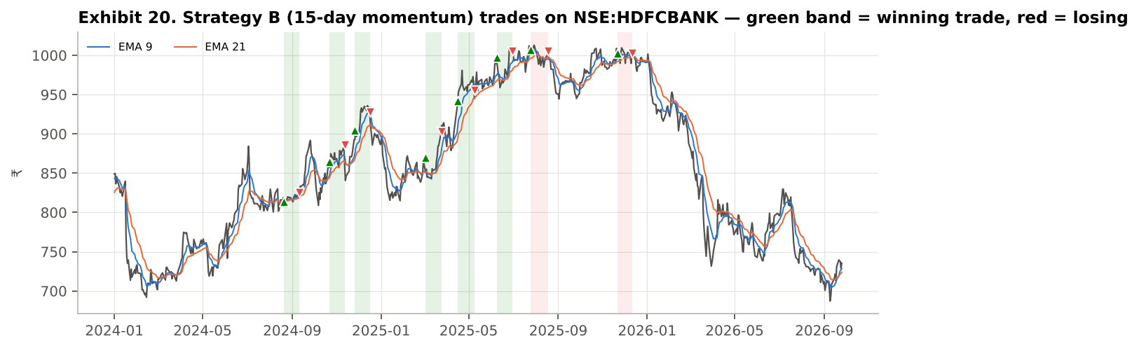
Exhibit 20. Strategy B on NSE:HDFCBANK since Jan 2024: 8 trades, 75% winners.
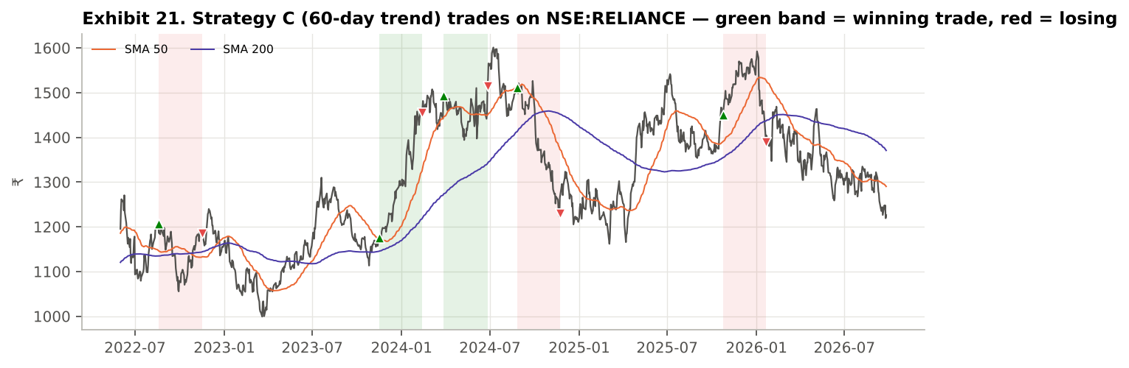
Exhibit 21. Strategy C on NSE:RELIANCE since Jun 2022: 5 trades, 40% winners — a reminder that even the best strategy has long dry spells on individual stocks, which is where biases take over.

4.5 In-sample versus out-of-sample
Table 4.5 Sharpe ratio by period (rules fixed in advance; no re-optimisation)
Stock | A: 2015–21 | A: 2022–26 | B: 2015–21 | B: 2022–26 | C: 2015–21 | C: 2022–26
RELIANCE | -0.14 | -0.51 | 0.58 | -0.71 | 0.71 | -0.04
HDFCBANK | -0.55 | -0.49 | 0.40 | 0.14 | 0.44 | 0.26
INFY | 0.66 | -0.62 | -0.28 | -0.61 | 0.10 | -0.35
ITC | 0.02 | -0.23 | -0.99 | -0.32 | -0.30 | 0.74
MARUTI | 0.58 | -0.95 | 0.27 | -0.35 | 0.35 | -0.01
SUNPHARMA | 0.47 | 0.54 | -0.60 | -0.42 | -0.05 | 0.45
LT | -0.22 | -0.19 | 0.43 | -0.12 | -0.09 | 0.64
Even with no parameter fitting, performance is period-dependent. Strategy A's equal-weighted Sharpe fell from 0.35 in 2015–21 to -0.71 in 2022–26 (weaker on 4 of 7 stocks) and Strategy B's from 0.03 to -0.88 (weaker on 5 of 7), while Strategy C held up (0.44 and 0.42). Buy-and-hold also weakened, from 0.53 to 0.14: 2022–26 was a harder period for these seven stocks. This split is reused in Sections 5.2 and 6 as the test of whether a rule's apparent edge was real.

4.6 Live validation on TradingView
Each strategy script was run in TradingView's Strategy Tester on NSE:RELIANCE (daily, ADJ off, Jan 2015 onwards, run on 4 October 2026) and compared with the Python replication run under identical settings: 0.05% commission and no interest on idle cash, because TradingView's Strategy Tester does not credit interest. The validation therefore tests the logic, not the cost assumption; the scripts now default to 0.15%. Table 4.6 shows the two side by side.
Table 4.6 TradingView Strategy Tester versus Python replication, NSE:RELIANCE
Strategy | Trades (TV / Python) | Win rate (TV / Python) | Net P&L (TV / Python)
A — 7-day mean reversion | 41 / 40 | 46% / 48% | −11.3% / −10.5%
B — 15-day momentum | 37 / 37 | 51% / 51% | +36% / +42%
C — 60-day trend | 18 / 19 | 67% / 63% | +184% / +158%
The residual differences have identifiable causes: TradingView's series includes Muhurat-trading sessions and extends to 1 October 2026 (Python stops on 25 September), Strategy B's last TradingView trade was still open, and one borderline Strategy C trade in January 2021 is triggered in Python but not on TradingView; removing it gives +183.8% against TradingView's +184.2%. Twelve of Strategy A's first thirteen trades have identical entry and exit dates and prices on both platforms. Live testing also exposed two implementation issues, both now fixed: Pine's margin check silently rejected 100%-of-equity orders when the next open gapped up (28 trades instead of 40 until margin_long = 0 was set), and the data needed the corporate-action adjustments described in Section 2.2.

5. Behavioural Biases: Impact and Illustration (Requirements 3 and 4)
Technical analysis is unusually exposed to behavioural bias. Its inputs are charts rather than cash flows, its rules leave room for interpretation (which crossover, which threshold, which time frame), and its feedback is fast and noisy, so traders receive frequent, random rewards that are easy to misattribute to skill. Each of the eight biases below is treated in the same way: first how it affects a technical strategy (requirement 3); then a Pine Script illustration that makes the bias visible on a TradingView chart, together with a measured experiment on the seven stocks that shows its effect (requirement 4). Mitigation (requirement 5) follows in Section 6.
All eight illustrations live in one script, 17_Bias_Lab.pine. A drop-down input selects the bias; the script then draws the relevant overlay on the price chart and computes a live evidence table from the chart's own history (forward returns after the event, counts and hit rates), so the demonstration can be repeated on any of the seven stocks. The shared accumulator that powers every table is shown below; the full script is in Appendix B.
// forward-return accumulator used by every Bias Lab mode: [count, mean, hit-rate] of n-bar returns after an event
f_fwd(bool ev, int n) =>
var float s = 0.0
var int c = 0
var int h = 0
if ev[n] and not na(close[n])
r = close / close[n] - 1
s += r
c += 1
h += r > 0 ? 1 : 0
[c, c > 0 ? s / c : na, c > 0 ? float(h) / c : na]
The Python replication pools the same experiments across all seven stocks (which a single TradingView chart cannot do) and measures forward returns from the next session's open, i.e. as they could actually be traded. Every comparison is reported with a test statistic: a Welch t for differences in average returns and a two-proportion z for differences in hit rates; |t| or |z| above 1.96 is significant at 5%.
What these experiments can and cannot show. Each experiment measures what a bias would cost if it were written into a trading rule: for example, what happens to Strategy B's losers if they are held to breakeven. It does not measure how often real traders behave this way; that evidence comes from the literature cited for each bias and, for Indian retail traders, from SEBI's finding that 93% of individual F&O traders lost money over FY22–FY24 (SEBI, 2024). We grade each bias's evidence as clear, suggestive, mixed or not supported, and say why.

5.1 Confirmation bias

Impact on a technical-analysis strategy
Confirmation bias is the tendency to seek, notice and weight evidence that supports a belief already held, and to discount evidence against it (Nickerson, 1998). In technical analysis it takes two concrete forms. The first is indicator shopping: a trader who already wants to buy adds oscillators until enough of them agree, and counts each agreement as independent confirmation, although RSI, Stochastic, %B and MACD are all transformations of the same recent closing prices. The second is selective memory of charts: the trades where a pattern 'worked' are remembered and shown to others, while the failures are explained away. Both inflate confidence without adding information, so position sizes grow faster than the true edge.

Illustration — Pine Script Bias Lab, mode "1 Confirmation" (17_Bias_Lab.pine), and evidence from the 7 stocks
In this mode the script marks three kinds of RSI buy signal: grey circles for RSI crossing up through 35 alone, orange triangles when Stochastic and %B also show 'oversold' (two redundant confirmations), and green triangles when the confirmation instead comes from volume (OBV above its EMA), the only input not computed from closing prices. Two further rows test the added indicators: CCI below −100 (a fourth price-based oscillator) and MFI rising (volume-weighted). The evidence table reports each group's 10-session forward return and the rolling correlations ta.correlation(rsi, k, 250), ta.correlation(rsi, pctB, 250) and ta.correlation(cci, pctB, 250).
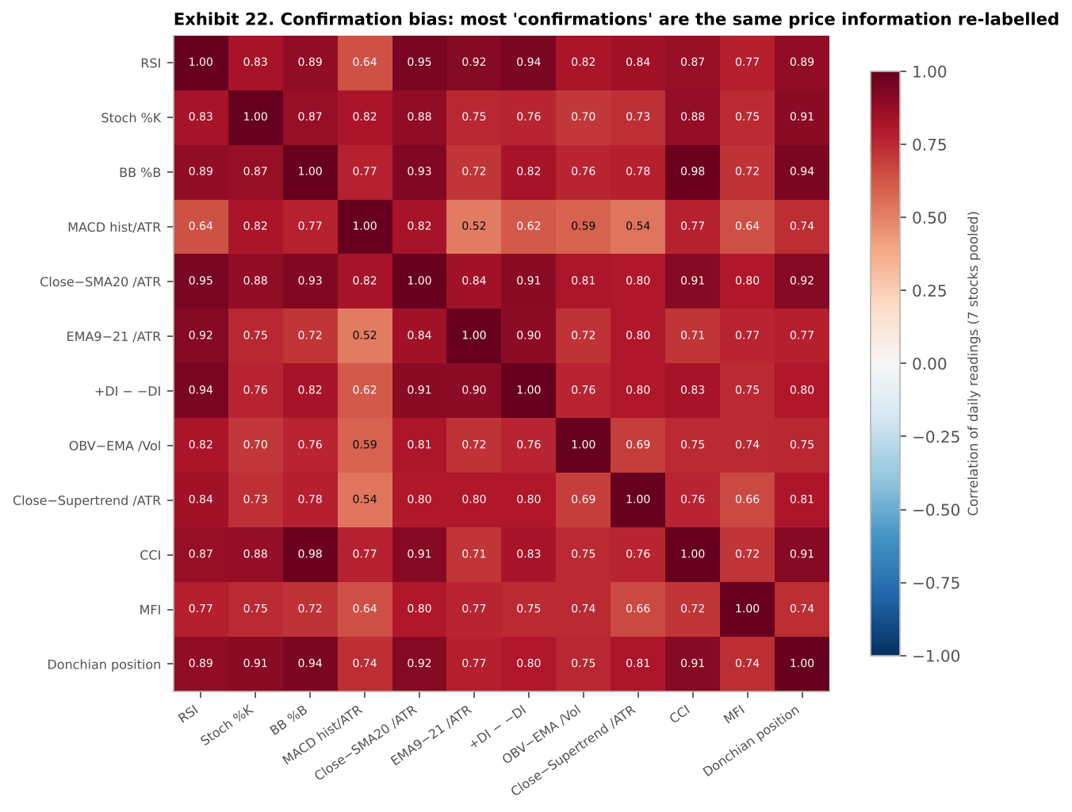
Exhibit 22. Correlation of the twelve indicators' daily readings, 7 stocks pooled (each oscillator normalised so that higher = more bullish). Almost every pair is correlated above 0.70: they are largely the same information.
Table 5.1 Does adding 'confirmations' improve an RSI signal? (10-session forward return, 7 stocks pooled)
Signal | n | Avg 10-day | Hit rate | z (hit vs alone)
RSI crosses up 35 (alone) | 434 | 0.40% | 54% | —
+ Stochastic oversold (redundant) | 392 | 0.46% | 54% | 0.12
+ Stoch + below lower BB (doubly redundant) | 249 | 0.55% | 54% | -0.03
+ CCI below −100 (redundant) | 356 | 0.59% | 54% | 0.16
+ OBV above its EMA (independent: volume) | 62 | 1.69% | 63% | 1.33
+ MFI rising (volume-weighted) | 229 | 0.62% | 55% | 0.16
+ Close above SMA200 (independent: trend) | 116 | 0.27% | 54% | 0.08
What the evidence shows. RSI's correlation with Stochastic is 0.83, with %B 0.89 and with the DMI spread 0.94. Requiring two such confirmations moved the hit rate only from 53.9% to 53.8% while discarding 43% of the signals: the trader feels far more certain about a signal that is barely better. The volume confirmation produced a much larger difference (average 1.69%, hit rate 63%), but on only 62 signals, and the difference is not statistically significant (z = 1.33); even OBV is correlated 0.82 with RSI because its sign is set by the close. The four indicators added in this version make the point sharper. CCI is correlated 0.98 with Bollinger %B, almost an identity, and the Donchian position 0.94: both are the same 20-day range seen through a different formula. Adding CCI as a confirmation moved the hit rate from 53.9% to 54.5% (n = 356). MFI, the second volume-based indicator, is the least correlated with RSI of all the oscillators (0.77), yet requiring it to be rising gave only 54.6% (n = 229). None of the redundant confirmations changed the hit rate by more than |z| = 0.2. Twelve indicators therefore offer more labels, not more independent evidence. Evidence grade: clear. Selective attention is illustrated by Strategy A's cross-section: an analyst who studied only SUNPHARMA would report a 9.7% CAGR, one who studied only HDFCBANK would report 3.1%, and the seven-stock average is 5.7%.

5.2 Overconfidence

Impact on a technical-analysis strategy
Overconfidence is the overestimation of one's own skill and the precision of one's information. Barber and Odean (2000, 2001) show that overconfident investors trade more and earn less after costs. In technical trading it appears as backtest overfitting — trying many parameter combinations and believing the best one, although its performance is partly luck (Bailey et al., 2014; Harvey, Liu & Zhu, 2016) — and as the hot-hand belief that a streak of winning trades shows the strategy, or the trader, is 'in form', which leads to larger positions just before normal performance returns (Gilovich, Vallone & Tversky, 1985).

Illustration — Pine Script Bias Lab, mode "2 Overconfidence" (17_Bias_Lab.pine), and evidence from the 7 stocks
The script shades the chart blue before a user-chosen split date (default 1 Jan 2022) and orange after it, marks every Strategy A signal, and reports the signal's 7-session forward return separately for the two periods. Moving the split date shows how often the period a trader 'learned' on flatters the period that follows. The disciplined strategy (18_Strategy_Disciplined.pine) adds the same split to TradingView's own closed-trade list as a live scorecard.
In Python we ran the overfitting experiment explicitly. For each stock we searched 25 versions of Strategy A (RSI thresholds 25–45 × holding periods 3–15 sessions, with at least five trades required) on 2015–21 only, selected the version with the highest Sharpe ratio, and then traded exactly that version on 2022–26.
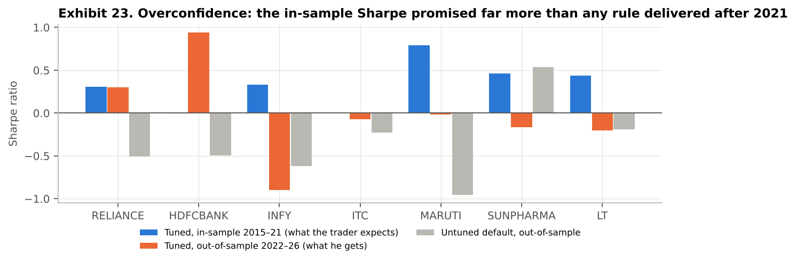
Exhibit 23. Sharpe of the best of 25 Strategy A variants in-sample (blue), the same variant out-of-sample (orange) and the untuned default out-of-sample (grey). Excess of a 6% cash return, net of 0.15% per side.
Table 5.2 Optimised in-sample versus out-of-sample (Strategy A family)
Stock | Chosen RSI | Chosen hold | Tuned IS Sharpe | Tuned OOS Sharpe | Default IS Sharpe | Default OOS Sharpe
RELIANCE | 40 | 15 | 0.31 | 0.30 | -0.14 | -0.51
HDFCBANK | 35 | 10 | -0.00 | 0.94 | -0.55 | -0.49
INFY | 45 | 15 | 0.33 | -0.90 | 0.66 | -0.62
ITC | 35 | 3 | 0.00 | -0.07 | 0.02 | -0.23
MARUTI | 35 | 7 | 0.79 | -0.01 | 0.58 | -0.95
SUNPHARMA | 45 | 15 | 0.46 | -0.16 | 0.47 | 0.54
LT | 40 | 10 | 0.44 | -0.20 | -0.22 | -0.19
Average |  |  | 0.33 | -0.02 | 0.12 | -0.35
What the evidence shows. The tuned rule promised an average Sharpe of 0.33 and delivered -0.02 on unseen data; 6 of 7 stocks got worse, Infosys from 0.33 to -0.90. This needs careful reading. The untuned default rule fell by a similar amount (0.12 to -0.35), and buy-and-hold also weakened after 2021, so most of the fall is a change of regime rather than overfitting alone; the tuned rule even did a little better out-of-sample than the default. The overconfidence is therefore not in tuning as such but in treating the in-sample number as a forecast: a trader who sized positions on a Sharpe of 0.33 received -0.02. The chosen parameters also differ from stock to stock (RSI 35–45, holds of 3–15 sessions), so the 'optimal' rule is largely noise, and selecting the best of 25 guarantees an upward-biased in-sample estimate (Bailey et al., 2014). On the hot hand, across 521 sequential trades from all strategies and stocks, the win rate after three straight wins was 50.7% (n = 75) against 52.6% overall (z = -0.33): streaks carry no information about the next trade. This is also why all twelve indicators run at their textbook settings on every stock. Evidence grade: clear.

5.3 Anchoring bias

Impact on a technical-analysis strategy
Anchoring is the reliance on an initial reference value when making estimates, with insufficient adjustment away from it (Tversky & Kahneman, 1974). Technical traders anchor on two values in particular. The first is their own entry price: a losing position is held 'until it gets back to cost', which is the disposition effect (Shefrin & Statman, 1985), and converts a time-bound strategy into an open-ended one. The second is salient chart levels such as the 52-week high, which many traders treat as a ceiling to sell into; George and Hwang (2004) argue that this anchoring causes under-reaction near the high.

Illustration — Pine Script Bias Lab, mode "3 Anchoring" (17_Bias_Lab.pine), and evidence from the 7 stocks
The script plots the 52-week high as a step line, shades sessions within 2% of it, and, if the user enters an entry price, draws that anchor and shades every session spent below it (the 'disposition zone'). The table compares 20-session forward returns near the 52-week high, far below it and on an average day, and prints the current distance from the user's anchor with the reminder that the market does not know anyone's cost.
In Python we took every losing trade of Strategy B across the seven stocks and replaced the disciplined 15-session exit with an anchored rule: keep holding until the close returns to the entry price plus costs, for up to a further year.
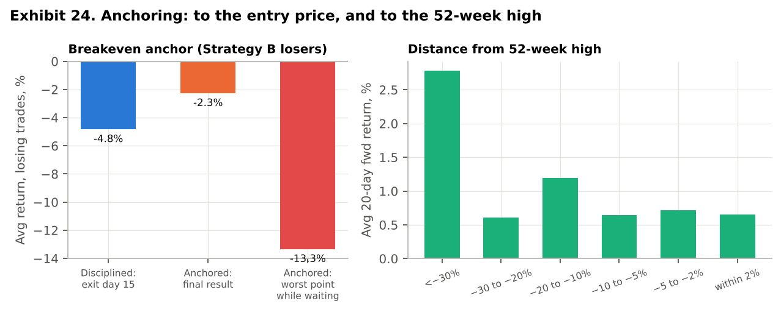
Exhibit 24. Left: Strategy B's losing trades under the disciplined exit and under a hold-to-breakeven anchor. Right: average 20-session forward return by distance from the 52-week high (7 stocks pooled).
Table 5.3 Distance from the 52-week high and the next 20 sessions
Distance from 52-week high | Sessions (n) | Avg 20-day return | Hit rate
<−30% | 1349 | 2.78% | 62%
−30 to −20% | 2716 | 0.61% | 55%
−20 to −10% | 5566 | 1.20% | 58%
−10 to −5% | 4793 | 0.65% | 53%
−5 to −2% | 3391 | 0.72% | 55%
within 2% | 2317 | 0.65% | 54%
What the evidence shows. Anchoring on the entry price "improved" the average losing trade from -4.8% to -2.3%, but at a cost the average hides: it tied up capital for 67 extra sessions per trade (about four and a half times the strategy's horizon), the position sat on an average worst loss of 13.3% while waiting, the worst case reached 56.1%, and 15% of losers had still not recovered after a year. The return 'improvement' is statistically significant (paired t = 3.22), which is exactly what makes the anchor persuasive; but it is bought with risk and time, and even crediting the disciplined exit with 67 sessions of Treasury-bill interest (about 1.6%) leaves a far smaller gap than the interim drawdowns suggest. The rule looks acceptable here only because the sample consists of today's large-cap survivors, which by construction recovered from most falls; on stocks that did not survive, the same anchor would have ridden losses towards zero. On the 52-week high, the George–Hwang pattern does not appear in this sample: sessions within 2% of the high were followed by 0.65% over 20 sessions, slightly below the average day, while stocks 30% or more below their high rebounded most (2.78%). The 52-week high therefore offered neither the resistance that anchored traders expect nor a reliable breakout signal. Evidence grade: clear on risk; the return effect is flattered by survivorship.

5.4 Representativeness bias

Impact on a technical-analysis strategy
Representativeness is judging probability by resemblance to a stereotype while ignoring base rates and sample size (Tversky & Kahneman, 1974). Technical analysis is built on stereotypes — 'overbought means a fall is due', 'a golden cross starts a bull market', 'three up days make a trend' — and on judging a pattern by how much the current chart looks like a memorable past example. Barberis, Shleifer and Vishny (1998) model how this leads investors to see trends in random sequences. The bias also shows up as trusting a strategy's first few trades as representative of its long-run behaviour (the 'law of small numbers').

Illustration — Pine Script Bias Lab, mode "4 Representativeness" (17_Bias_Lab.pine), and evidence from the 7 stocks
The script marks each RSI cross above 70 with a red ✕ and each 50/200 golden cross with a 'GC' label, and the table compares their forward returns with the base rate over the same horizon, together with three consecutive up-closes versus an average 5-session period.
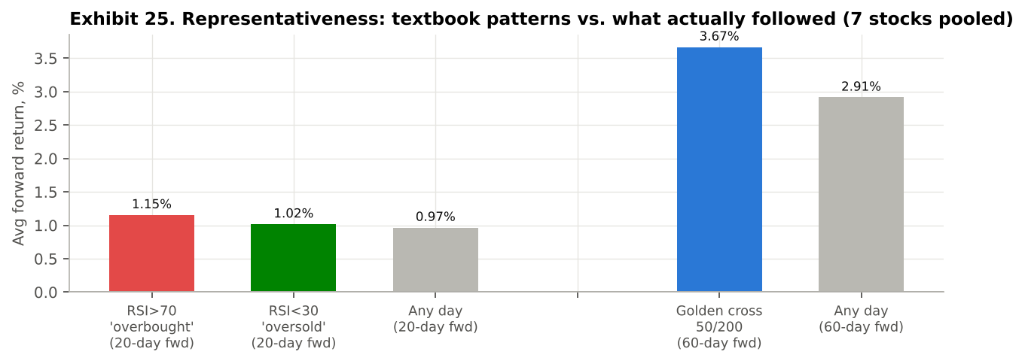
Exhibit 25. Forward returns after textbook patterns versus the unconditional base rate over the same horizon (7 stocks pooled).
Table 5.4 Stereotype versus base rate
Pattern | n | Avg forward return | Hit rate | t vs base rate
RSI > 70 ('overbought') | 415 | 1.15% | 57% | 0.58
RSI < 30 ('oversold') | 219 | 1.02% | 60% | 0.07
Unconditional (any day) | 20181 | 0.97% | 56% | —
Golden cross 50/200, 60d | 59 | 3.67% | 59% | 0.45
Unconditional, 60d | 19901 | 2.91% | 59% | —
3 up-closes in a row, 5d | 2495 | 0.14% | 52% | -1.42
Unconditional, 5d | 20286 | 0.25% | 53% | —
Table 5.5 The first five trades are not representative (Strategy C)
Stock | Win rate, first 5 trades | Win rate, all trades | All trades (n)
RELIANCE | 80% | 63% | 19
HDFCBANK | 100% | 77% | 13
INFY | 60% | 57% | 7
ITC | 40% | 40% | 5
MARUTI | 60% | 56% | 9
SUNPHARMA | 80% | 67% | 12
LT | 40% | 53% | 15
What the evidence shows. 'Overbought' was not bearish: after RSI crossed above 70 the next 20 sessions returned 1.15%, slightly more than the 0.97% base rate, consistent with momentum. The golden cross beat the 60-session base rate (3.67% vs 2.91%) but had the same hit rate (59% vs 59%) and occurred only 59 times in nearly twelve years across seven stocks, too few to rely on. Three up-closes in a row were followed by below-average returns (0.14% vs 0.25%), the opposite of 'trend'. Finally, Strategy C's first five trades overstated its eventual win rate on 5 of 7 stocks, by up to 23 pp on HDFC Bank: an early run of wins looked representative of a far better strategy than the full sample supports. None of the textbook patterns differs significantly from its base rate (all |t| < 1.5): the stereotype carries no information in either direction. Evidence grade: clear.

5.5 Recency bias

Impact on a technical-analysis strategy
Recency bias is over-weighting the most recent observations relative to the full history. Investors extrapolate recent returns into expectations (Greenwood & Shleifer, 2014). A technical trader shows it in two ways: by switching strategies to whichever one worked over the last few weeks, abandoning a sound rule during its normal drawdown; and by shortening indicator look-backs after a missed move so that the newest bars dominate, which produces fast signals and frequent whipsaws.

Illustration — Pine Script Bias Lab, mode "5 Recency" (17_Bias_Lab.pine), and evidence from the 7 stocks
The script plots a recency-heavy EMA 5/10 pair alongside the SMA 50/200, marks every EMA 5/10 crossing with a pink diamond, and reports crossings per year for both. In Python we simulated a trader who, at the start of each month, moves each stock's capital into whichever of Strategies A, B or C had the best return over the previous three months, and compared this with a fixed one-third allocation to each.
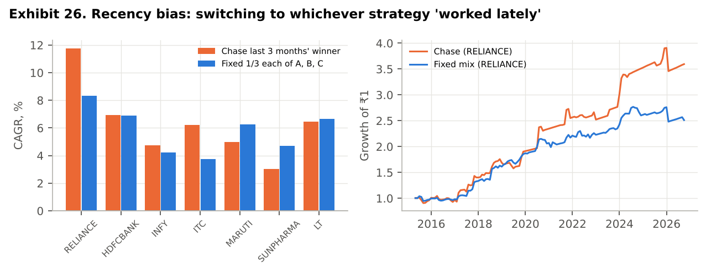
Exhibit 26. Left: CAGR of chasing last quarter's best strategy versus a fixed equal mix, by stock. Right: the two approaches on Reliance.
Table 5.6 Chasing the recent winner versus a fixed mix (monthly rebalancing, Apr 2015 – Sep 2026)
Stock | Chase: CAGR | Fixed mix: CAGR | Chase: Sharpe | Fixed mix: Sharpe | Strategy switches
RELIANCE | 11.8% | 8.3% | 0.44 | 0.26 | 45
HDFCBANK | 6.9% | 6.9% | 0.13 | 0.16 | 54
INFY | 4.7% | 4.2% | -0.11 | -0.30 | 44
ITC | 6.2% | 3.8% | 0.04 | -0.46 | 34
MARUTI | 5.0% | 6.3% | -0.05 | 0.05 | 46
SUNPHARMA | 3.0% | 4.7% | -0.32 | -0.14 | 45
LT | 6.5% | 6.7% | 0.08 | 0.10 | 47
What the evidence shows. Chasing the recent winner raised the compound return on 4 of 7 stocks and lowered the excess Sharpe ratio on 4 of 7: it helped on about half the stocks and hurt on the rest, which is what a coin toss would produce, and it required about 45 switches over 138 months, whose tax is not charged here. Recent performance contained no reliable information about which strategy would do best next. The look-back experiment is unambiguous: an EMA 5/10 pair crossed 21.3 times a year, against 10.7 for EMA 9/21 and 1.5 for SMA 50/200; each crossing is a reaction to the most recent bars, and at 0.15% a side each round trip costs 0.3%. Evidence grade: mixed (no consistent cost or benefit).

5.6 Conservatism bias

Impact on a technical-analysis strategy
Conservatism is the slow updating of beliefs when new evidence arrives (Edwards, 1968); Barberis, Shleifer and Vishny (1998) use it to explain under-reaction. It is the mirror image of recency. A trader who has been profitable with a bullish view keeps reading new weakness as 'noise' and waits for the slowest possible confirmation before acting. Many classical trend rules embody conservatism by design: a 50/200 death cross needs months of data to change its mind. The cost is that exits arrive after much of the damage is done, and re-entries after much of the recovery.

Illustration — Pine Script Bias Lab, mode "6 Conservatism" (17_Bias_Lab.pine), and evidence from the 7 stocks
The script plots the fast EMA 21 against the slow SMA 200 and shades in amber every session in which the fast evidence has turned bearish (close and EMA 9 below EMA 21) while the slow belief is still bullish (close above SMA 200). Death crosses are labelled 'DC'. The table reports how far below its 120-session high the stock already was, on average, when each rule turned bearish. We measured the same thing in Python around the COVID-19 crash, from each stock's pre-crash peak (January–February 2020).
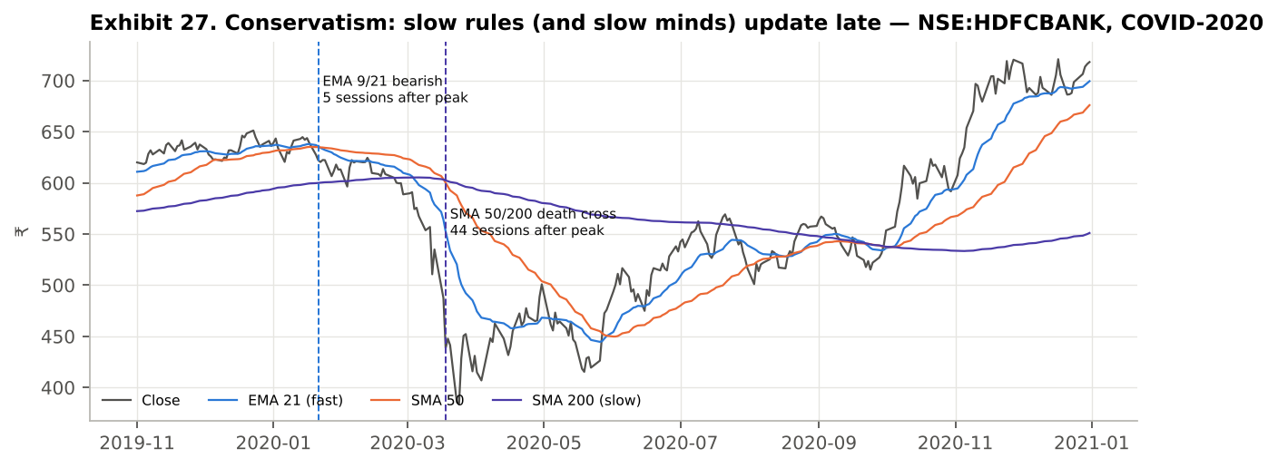
Exhibit 27. HDFC Bank, Nov 2019 – Dec 2020: the fast rules turned bearish days after the peak; the SMA 50/200 death cross arrived near the bottom, and the slow averages then lagged the recovery.
Table 5.7 Sessions from the pre-COVID peak until each rule turned bearish (fall from peak at that point)
Stock | Peak | Peak-to-trough | EMA 9/21 bearish | Supertrend flips down | Close < SMA 200 | SMA 50/200 death cross
RELIANCE | 2020-01-17 | -44% | 3 d (-3%) | already | 29 d (-16%) | 45 d (-40%)
HDFCBANK | 2020-01-14 | -40% | 5 d (-4%) | 9 d (-6%) | 14 d (-7%) | 44 d (-32%)
INFY | 2020-02-19 | -34% | 6 d (-9%) | 6 d (-9%) | 6 d (-9%) | 18 d (-33%)
ITC | 2020-01-14 | -39% | already | already | already | already
MARUTI | 2020-01-17 | -47% | 5 d (-5%) | 7 d (-7%) | 25 d (-14%) | 44 d (-44%)
SUNPHARMA | 2020-01-17 | -29% | 11 d (-8%) | 11 d (-8%) | 11 d (-8%) | 41 d (-20%)
LT | 2020-01-30 | -48% | 4 d (-4%) | 2 d (-6%) | already | already
'already' means the rule was bearish at the peak itself (ITC was in a down-trend before COVID; L&T had already fallen below its 200-day average; Reliance's Supertrend was already in its down-trend state).
What the evidence shows. Where it applied, the fast EMA rule turned within 3–11 sessions when prices were on average 5.5% below the peak, and the volatility-scaled Supertrend flipped within 2–11 sessions at an average 7.1% below the peak. The death cross needed 38 sessions on average, by which time prices were 34% below the peak — on Reliance and Maruti the 'sell' signal arrived after 40% and 44% falls, effectively at the bottom. The trade-off with recency (Section 5.5) is explicit: the fast rule reacts early but whipsaws 7 times as often. Neither extreme is 'unbiased'; the choice of speed must be made in advance and matched to the strategy's horizon. Evidence grade: suggestive, because it rests on a single crash observed on five usable stocks.

5.7 Herding

Impact on a technical-analysis strategy
Herding is following the actions of others rather than one's own information (Bikhchandani, Hirshleifer & Welch, 1992; Lakonishok, Shleifer & Vishny, 1992). Technical analysis encourages herding because so many traders watch the same indicators with the same default settings: when a breakout is visible on every screen, buying it feels safe precisely because everyone else is buying. The consequences are crowded entries at stretched prices, and fragile moves that reverse once the crowd has finished buying. Breadth of agreement across stocks — 'everything is flashing buy' — is the market-level version of the same pressure.

Illustration — Pine Script Bias Lab, mode "7 Herding" (17_Bias_Lab.pine), and evidence from the 7 stocks
The script calls request.security() on all seven stocks to count how many are in the same bullish state (EMA 9 > EMA 21 and MACD above signal) on each day, shades crowded sessions (6–7 of 7) in red and isolated ones (≤ 3 of 7) in blue, flags volume-spike breakouts (volume above twice its 20-day average with a gain of more than 3%) and marks every Donchian 20-day breakout, the most widely watched breakout rule, with a purple diamond. The table compares forward returns of Strategy B signals by crowding, and of joining volume-spike breakouts.
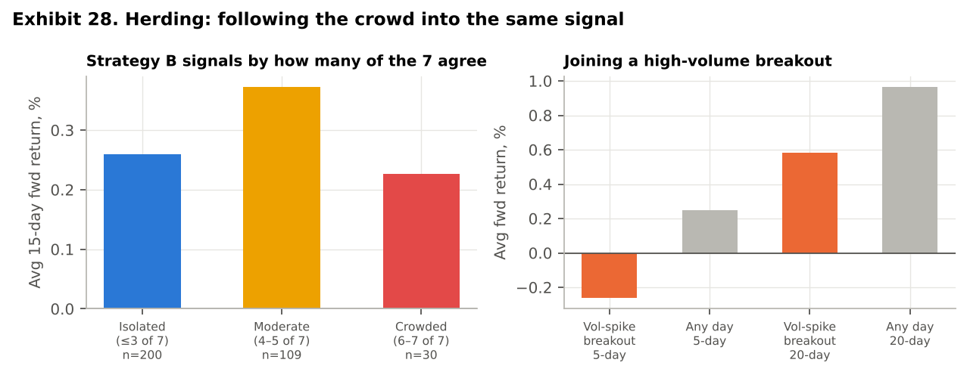
Exhibit 28. Left: 15-session forward return of Strategy B signals by how many of the seven stocks were in the same bullish state. Right: joining a high-volume breakout versus an average day.
Table 5.8 Following the crowd
Situation | n | Avg forward return | Hit rate
Strategy B signal — Isolated (≤3 of 7) (15d) | 200 | 0.26% | 56%
Strategy B signal — Moderate (4–5 of 7) (15d) | 109 | 0.37% | 51%
Strategy B signal — Crowded (6–7 of 7) (15d) | 30 | 0.23% | 50%
Volume-spike breakout (5d) | 235 | -0.26% | 52%
Any day (5d) | 20286 | 0.25% | 53%
Volume-spike breakout (20d) | 234 | 0.58% | 53%
Donchian 20-day breakout (5d) | 987 | 0.09% | 51%
Donchian 20-day breakout (20d) | 987 | 0.77% | 55%
Any day (20d) | 20181 | 0.97% | 56%
Test statistics against the average day: volume-spike breakout t = -1.81 (5 days) and -0.79 (20 days); Donchian breakout t = -1.46 and -0.93, and t = -2.20 over 10 days (Table 3.1). Crowded versus isolated hit rate: z = -0.62.
What the evidence shows. Joining high-volume breakouts was costly: the next 5 sessions returned -0.26% against 0.25% on an average day, and the next 20 sessions 0.58% against 0.97% — the move was largely over by the time it was obvious. The Donchian breakout, which every charting package draws by default, tells the same story on a much larger sample (n = 987): 0.09% over 5 sessions and 0.77% over 20, both below the average day. Strategy B signals taken when 6–7 of the seven stocks were already bullish returned 0.23% with a 50% hit rate, the worst of the three groups, although the crowded sample is small (n = 30) and the moderate group did best, so the relationship is not monotonic. The defensible conclusion is narrower than the textbook's: signals that everyone can see at the same moment carry no extra edge, and buying the most visible breakouts carried a penalty that is significant at the 10-day horizon (t = -2.20) and borderline at 5 days. Evidence grade: suggestive.

5.8 FOMO (fear of missing out)

Impact on a technical-analysis strategy
FOMO is the anxiety that others are profiting from an opportunity one is missing (Przybylski et al., 2013). In trading it shows up as entering late, after a signal has already played out, and as abandoning entry rules to buy extended prices because 'it keeps going up'. It is closely related to herding but is driven by regret aversion: the pain of watching a move without participating outweighs the analysis. In a rules-based strategy, FOMO adds trades that the rules did not generate or takes the rule's trades at worse prices.

Illustration — Pine Script Bias Lab, mode "8 FOMO" (17_Bias_Lab.pine), and evidence from the 7 stocks
The script draws a 'chase line' at EMA 21 + 1.5 × ATR and shades sessions in red when price is above it or RSI is above 70. Strategy B signals are marked green when taken calmly and red when taken while extended; the table compares the two groups and also measures the same signal taken five sessions late. In Python we re-ran Strategies B and C with entries delayed by 0, 2, 5 and 10 sessions, and split Strategy B's actual trades by how extended the price was at entry.
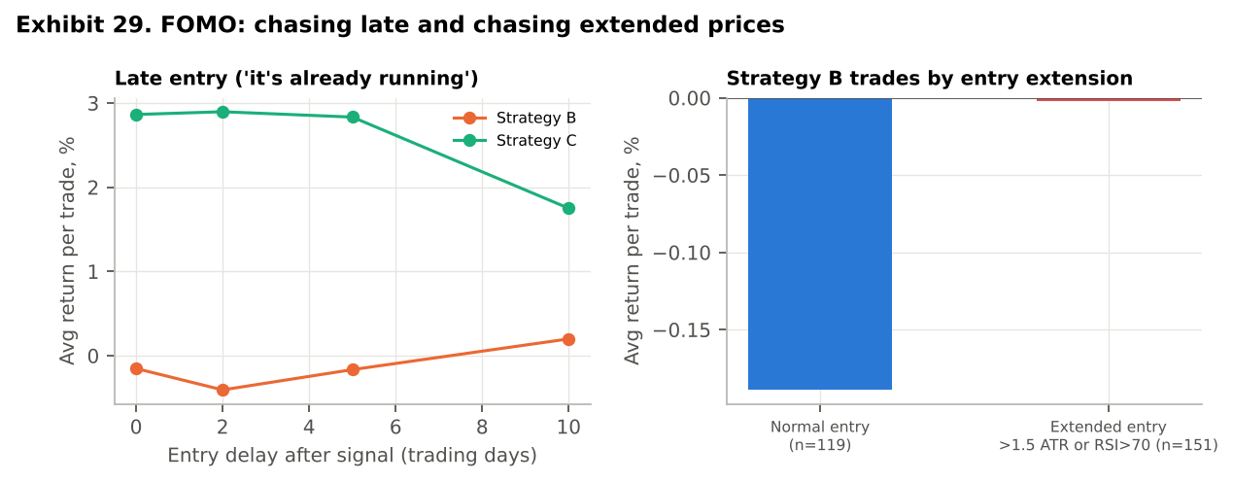
Exhibit 29. Left: average return per trade when entry is delayed after the signal. Right: Strategy B trades split by entry extension.
Table 5.9 Late and extended entries
Entry | Strategy B avg trade | Strategy C avg trade
On signal (next open) | -0.15% | 2.86%
2 sessions late | -0.41% | 2.90%
5 sessions late | -0.17% | 2.83%
10 sessions late | 0.20% | 1.75%
What the evidence shows. For the 60-day trend strategy, lateness was costly but not immediately: a 2–5 session delay barely mattered (2.90% and 2.83% vs 2.86% per trade), while a 10-session delay cut the average trade by 1.1 pp, about 39%. For the 15-day momentum strategy, delay made no systematic difference because its edge per trade is close to zero anyway. Contrary to the textbook expectation, Strategy B trades entered at extended prices (n = 151) did slightly better than calm entries (-0.00% vs -0.19%; hit rate 55% vs 49%), consistent with short-term momentum in large caps. We report this rather than force the narrative: FOMO's damage in this sample comes from lateness on long-horizon trades and from the herding-style breakout chasing in Section 5.7, not from extension per se. The 10-session penalty on Strategy C is also not statistically significant (t = 0.63 on 80 trades). This also matters for mitigation: an anti-FOMO filter that blocks extended entries is not automatically beneficial, and has to be tested before it is adopted (Section 6). Evidence grade: not supported in this sample.

6. Mitigating the Biases (Requirement 5)
The common thread in Section 5 is that every bias enters through a discretionary decision made after seeing the data: which indicators count as confirmation, which parameters to believe, when to exit a loser, which strategy to switch to, whether to chase. Mitigation therefore has three parts. The first is to remove discretion by writing the decision into code before the trade, so the rule cannot be bent in the moment. The second is to decide which rules to adopt using data the rule has not seen, so that the mitigation itself does not become another overfitted belief. The third, which the results below make the most important, is a hurdle: a rule must beat what its capital would earn in Treasury bills after realistic costs, or it is dropped.

6.1 Bias-by-bias mitigation and its Pine Script implementation
Table 6.1 Mitigation toolkit
Bias | Mitigation | Pine Script implementation | Evidence in this report
Confirmation | Confirm only with independent information (volume, trend regime, a different horizon); write the pass/fail test before looking at the chart; review all trades, not chosen ones | M3: obv > ta.ema(obv,20) in 18; Bias Lab mode 1 prints the correlation of the 'confirmations' | Price-based confirmations correlate 0.64–0.95 with RSI and change its hit rate by |z| < 0.2 (Table 5.1)
Overconfidence | Fix parameters in advance; hold out an out-of-sample period; treat in-sample results as optimistic; size from volatility, never from a streak | Fixed inputs; pre-registered split input and IS/OOS scorecard from strategy.closedtrades in 18 | Promised Sharpe 0.33, delivered -0.02; no hot hand (Table 5.2)
Anchoring | Exit on time or on a volatility stop that ignores the entry price; never average down to 'get back to cost' | Time exit via strategy.opentrades.entry_bar_index; M1: strategy.exit(stop = close − k·ATR) | Hold-to-breakeven: +67 sessions, -13.3% interim loss, 15% never recover (Section 5.3)
Representativeness | Judge every pattern against its base rate and sample size; demand a minimum number of trades before believing a result | Bias Lab mode 4 prints the base rate next to every pattern | No textbook pattern differs from its base rate, |t| < 1.5 (Tables 5.4–5.5)
Recency | Allocate across strategies by rule, not by last quarter; match look-back to horizon | One fixed strategy per horizon, adopted only if it clears the cash hurdle | Chasing lowered the Sharpe ratio on 4 of 7 stocks (Table 5.6)
Conservatism | Pair a slow trend filter with a fast, pre-defined risk exit; decide in advance what evidence changes the view | Horizon-scaled ATR stop alongside SMA/ADX filters; Bias Lab mode 6 shades the lag zone | Death cross arrived 38 sessions and 34% below the COVID peak (Table 5.7)
Herding | Trade only own pre-defined signals; treat extreme breadth, volume spikes and textbook breakouts as warnings, not triggers | Bias Lab mode 7: breadth count via request.security on 7 stocks; breakout markers | Donchian breakouts trail the average day (t = -2.20 at 10 days) (Table 5.8)
FOMO | Never enter without a signal; if a signal is missed by more than a set number of bars, skip it; test any 'no-chase' filter before using it | M2: anti-FOMO filter in 18 (tested, not assumed); entry gated on the signal bar | 10-session delay cut Strategy C's average trade by ~39%, not significant (Table 5.9)

6.2 Testing the mitigations: chosen in-sample, judged out-of-sample
A mitigation that is adopted because it looks good on the full history is itself a product of overconfidence and hindsight. We therefore pre-registered six candidate versions of each strategy: M0 as built; M1 a horizon-scaled ATR stop (2×, 3× and 4× ATR for A, B and C); M2 an anti-FOMO entry filter; M3 independent volume confirmation; M4 = M1 + M3; and M5 a Supertrend (10, 3) trailing exit, which gives one of the four added indicators a concrete job. For each strategy we chose the candidate with the highest equal-weighted Sharpe ratio on 2015–21 only, and then judged every candidate on 2022–26. All candidates are switches in 18_Strategy_Disciplined.pine, whose 'In-sample chosen' preset reproduces the selection.
Table 6.2 Candidate de-biasing rules (equal-weighted 7-stock portfolio; excess Sharpe, net of 0.15% per side)
Strat. | Candidate | IS Sharpe | OOS Sharpe | OOS CAGR | OOS avg stock DD | Trades (full)
A | M0 Naive (as built) ← chosen | 0.35 | -0.71 | 4.3% | -10.4% | 234
A | M1 Horizon-scaled ATR stop | 0.29 | -0.68 | 4.4% | -8.4% | 249
A | M2 Anti-FOMO entry filter | 0.35 | -0.71 | 4.3% | -10.4% | 234
A | M3 Independent volume confirmation | 0.06 | -0.26 | 5.8% | -5.0% | 53
A | M4 ATR stop + volume confirmation | -0.08 | -0.54 | 5.5% | -3.8% | 53
A | M5 Supertrend trailing exit | -0.32 | -1.42 | 4.1% | -5.5% | 322
B | M0 Naive (as built) | 0.03 | -0.88 | 2.7% | -16.0% | 270
B | M1 Horizon-scaled ATR stop ← chosen | 0.10 | -0.69 | 3.6% | -11.9% | 276
B | M2 Anti-FOMO entry filter | -0.37 | -0.26 | 5.5% | -8.9% | 129
B | M3 Independent volume confirmation | 0.03 | -0.88 | 2.7% | -16.0% | 270
B | M4 ATR stop + volume confirmation | 0.10 | -0.69 | 3.6% | -11.9% | 276
B | M5 Supertrend trailing exit | -0.08 | -0.80 | 3.4% | -13.0% | 282
C | M0 Naive (as built) ← chosen | 0.44 | 0.42 | 8.5% | -18.9% | 80
C | M1 Horizon-scaled ATR stop | 0.19 | 0.00 | 6.0% | -17.1% | 85
C | M2 Anti-FOMO entry filter | 0.37 | 0.63 | 9.0% | -14.8% | 61
C | M3 Independent volume confirmation | 0.41 | 0.33 | 7.8% | -18.9% | 73
C | M4 ATR stop + volume confirmation | 0.10 | -0.13 | 5.4% | -17.1% | 77
C | M5 Supertrend trailing exit | 0.13 | 0.33 | 7.3% | -10.3% | 108
Notes: M2 is identical to M0 for Strategy A because A buys oversold dips, which are never 'extended'; M3 is identical to M0 for Strategy B because B already requires OBV confirmation. OOS CAGR includes interest on idle cash.
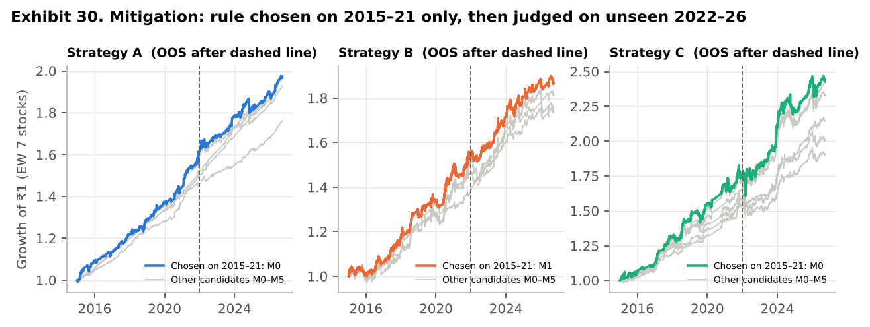
Exhibit 30. Each strategy's chosen rule (bold) against the other candidates (grey); the dashed line marks the start of the out-of-sample period.
What the test shows. For Strategy B the in-sample choice was the ATR stop; out-of-sample it narrowed the loss (Sharpe -0.88 to -0.69; average per-stock drawdown -16.0% to -11.9%) but B remained well below the cash hurdle. For Strategies A and C no overlay beat the original rule in-sample, so the disciplined choice was to add nothing. The Supertrend trailing exit (M5) was worse than the original rule in-sample for all three strategies and was rejected; out-of-sample it would also have lowered Strategy C's Sharpe (0.42 to 0.33). Two lessons follow. First, "more rules" is not "less bias": the volume confirmation that looked attractive in Table 5.1 cut Strategy A's trades by three-quarters, and stops on the 60-day strategy reduced its returns in both periods. Second, hindsight is tempting: the anti-FOMO filter (M2) would have been the best choice for Strategy C out-of-sample (Sharpe 0.63), but nothing in the 2015–21 data justified choosing it; switching to it now would be recency bias in action.

6.3 The out-of-sample verdict: subtraction beats addition
Rules chosen on 2015–21 can only be judged fairly on 2022–26; a full-period figure mixes the period used for the choice with the period used to judge it. Exhibit 31 and Table 6.3 therefore report the out-of-sample period alone.
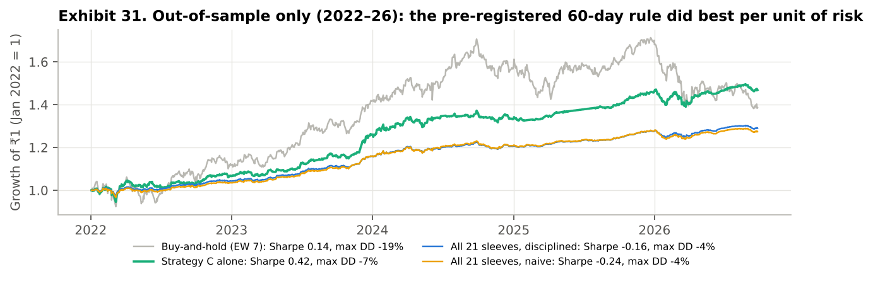
Exhibit 31. Out-of-sample only (Jan 2022 – Sep 2026): Strategy C alone, the 21-sleeve portfolios and equal-weighted buy-and-hold, each rebased to 1.
Table 6.3 Out-of-sample results, Jan 2022 – Sep 2026 (excess Sharpe ± one standard error)
Portfolio | Sharpe ± SE | CAGR | Max drawdown
Strategy C alone (pre-registered, no overlay) | 0.42 ± 0.48 | 8.5% | -7.0%
Buy-and-hold, equal-weighted 7 stocks | 0.14 ± 0.46 | 7.1% | -19.3%
21 sleeves (A + B + C), disciplined | -0.16 ± 0.46 | 5.5% | -3.9%
21 sleeves (A + B + C), naive | -0.24 ± 0.47 | 5.3% | -4.3%
Strategy C, specified in advance and never re-tuned, beat buy-and-hold on unseen data on every measure: Sharpe 0.42 against 0.14, return 8.5% against 7.1%, and a maximum drawdown of -7.0% against -19.3%. We do not claim this proves skill: with 4.7 years of data the standard error of each Sharpe ratio is about ±0.5, so the difference is within sampling noise. Combining all 21 sleeves, by contrast, lowered the out-of-sample Sharpe to -0.16, because Strategies A and B lost money relative to cash after 2021. Diversification across rules helps only when each rule clears the hurdle on its own; the decisive de-biasing step here was to drop A and B, which is the hardest step behaviourally because it means admitting that two of three strategies we built do not work.

6.4 A pre-trade checklist enforced in code
The disciplined strategy draws a red ✕ wherever a base signal was vetoed by an active filter and a scorecard showing in-sample and out-of-sample results side by side, so the user sees both what the rules refused to do and whether the edge is surviving. Together with the Bias Lab, it turns the checklist below from good intentions into chart objects:
- Hurdle: does the rule beat Treasury bills after realistic costs (0.15% a side, not the brokerage headline of zero)? If not, it is not traded.
- Before the trade: is there a signal from the pre-registered rule, generated on this bar (not five bars ago)? Is the confirmation from independent information?
- Sizing: is the position sized by the rule, regardless of the last few results?
- Exit: is the exit fixed in advance (time and/or ATR stop), with no reference to the entry price?
- Review: are all trades reviewed, including losers and missed signals, and is the out-of-sample record compared with the in-sample record before any rule is changed?
- Change control: is any rule change tested on data it was not designed on, and adopted only if it improves out-of-sample results?

6.5 Robustness: what would change our conclusions
Three assumptions could plausibly overturn the findings: the cost per trade, the return on idle cash and sampling error. Table 6.4 re-runs the three strategies and buy-and-hold under each combination of cost and cash rate (with a 0% cash rate the Sharpe ratio is the raw ratio).
Table 6.4 Sharpe ratio under alternative cost and cash assumptions
Cost per side | Cash rate | A full | B full | C full | B&H full | C OOS | B&H OOS
0.05% | 0% | 0.35 | 0.18 | 0.62 | 0.67 | 0.75 | 0.58
0.05% | 6% | 0.18 | -0.09 | 0.36 | 0.32 | 0.46 | 0.14
0.15% | 0% | 0.15 | 0.03 | 0.58 | 0.67 | 0.71 | 0.58
0.15% | 6% | -0.02 | -0.24 | 0.33 | 0.32 | 0.42 | 0.14
0.25% | 0% | -0.06 | -0.12 | 0.54 | 0.67 | 0.67 | 0.58
0.25% | 6% | -0.22 | -0.39 | 0.29 | 0.32 | 0.37 | 0.14
Shaded row = base case. Full = Jan 2015 – Sep 2026; OOS = Jan 2022 – Sep 2026.
- Costs decide A and B. At 0.05% a side with no cash return, A and B look acceptable (Sharpe 0.35 and 0.18); once a realistic cost and the cash alternative are counted, both fall below zero. Strategy C stays positive in every cell, between 0.29 and 0.62, because it trades only about once a year per stock, so costs barely touch it.
- The cash rate decides the comparison with buy-and-hold. With cash earning nothing, buy-and-hold's Sharpe (0.67) is above C's (0.58); with cash earning 6% the two are level (0.32 and 0.33). A zero rate is not a neutral assumption in India; it penalises any strategy that holds cash.
- Sampling error limits every Sharpe comparison. The standard error of a 12-year Sharpe ratio is about ±0.30 and of a 4.7-year one about ±0.5 (Lo, 2002). We therefore state C's advantage as a much smaller drawdown, which holds in every row of Table 6.4, with a Sharpe ratio level with buy-and-hold once cash earns its Treasury-bill rate, rather than as a statistically proven outperformance.
- What would change our mind. A point-in-time universe in which buy-and-hold suffers from delisted stocks would favour the timing rules; a period without a deep crash (no 2020) would favour buy-and-hold; and at 0.25% a side, the highest cost tested, C's Sharpe fell to 0.29, just below buy-and-hold's 0.32, so costs much above that level would remove its advantage.

7. Limitations
- Survivorship bias. The seven stocks are today's large caps applied back to 2015. Stocks that fell out of the Top 100 are absent, which flatters buy-and-hold and the hold-to-breakeven anchor in Section 5.3, and may flatter mean-reversion rules generally. A point-in-time Top-100 universe would correct this.
- Small samples and sampling error. Strategy C produces 5–19 trades per stock, several bias tests rest on a few dozen events (crowded signals, n = 30; volume-confirmed RSI signals, n = 62), and the conservatism test rests on one crash. We report n and a test statistic with every comparison and grade the evidence accordingly.
- Bias prevalence is not measured. The experiments measure the cost of a bias written into a rule, not how often traders exhibit it; prevalence is taken from the literature and from SEBI (2024).
- Replication versus screenshots. Pooled exhibits are generated from a Python replication of the Pine logic, because TradingView cannot pool seven stocks or run parameter grids on one chart. The live validation (Section 4.6) used 0.05% costs and no interest on cash, since the Strategy Tester credits none; small residual differences remain for the reasons given there.
- Costs and cash. 0.15% per side is an estimate for liquid large caps; short-term capital-gains tax and position-size-dependent slippage are not modelled. The 6% cash rate is a constant approximation of a 91-day Treasury-bill yield that ranged from roughly 3.3% to 7.5% over the period.
- Multiple testing. We ran many experiments. Each was specified before its result was seen and is reported whether or not it supported the hypothesis, but with dozens of comparisons a few 'significant' results at 5% are expected by chance; the two significant indicator results are both negative, which is the less flattering direction.

8. Conclusion and Recommendations
Twelve standard indicators, implemented in Pine Script and tested on seven NSE large caps from seven sectors, show no statistically detectable edge on their own; the only significant results are negative. Combined into horizon strategies and charged realistic Indian costs, the 7- and 15-day strategies earn less than Treasury bills. The 60-day trend strategy matches buy-and-hold's risk-adjusted return with about a third of its drawdown over the full period, and on unseen 2022–26 data it did better than buy-and-hold on every measure (Sharpe 0.42 against 0.14), though not by a margin that is statistically secure.
That thin, noisy edge is exactly why behavioural biases matter. The data were noisy enough that an analyst could have 'confirmed' an RSI edge on Sun Pharma, optimised Strategy A to a Sharpe of 0.8 on Maruti, held losers to breakeven and called it patience, or waited for a death cross and sold near the COVID bottom. The evidence is clear for confirmation, overconfidence, representativeness and anchoring, suggestive for herding and conservatism, mixed for recency and not supported for FOMO, and we report it as found.
The mitigation that worked was procedural, and it was subtraction rather than addition: write the rules in code before the trade, use independent rather than redundant confirmation, exit on time or volatility rather than on the entry price, choose any change on in-sample data and judge it out-of-sample, and drop any rule that does not beat Treasury bills after costs. Pine Script is well suited to this because it can enforce all of these steps on the chart itself.

Recommendations for a retail broker or robo-advisory platform
- Default to long horizons. Rule-based retail strategies should start from 60-day-type horizons; at realistic costs and with cash earning its Treasury-bill rate, the 7- and 15-day rules did not beat Treasury bills.
- Show the hurdle before the order. Display the all-in cost of the round trip (about 0.3% here, not 'zero brokerage') and the Treasury-bill return the capital would otherwise earn.
- Put base rates beside patterns. Any chart-pattern alert should carry its historical base rate and sample size, as the Bias Lab does; this addresses representativeness and confirmation at the point of decision.
- Never show an optimised backtest alone. Show it next to its out-of-sample record, as the disciplined strategy's scorecard does; this is the most direct defence against overconfidence.
- For the regulator. SEBI's F&O risk disclosure could be extended to high-turnover cash-market trading: a statement of cost per round trip and of how often short-horizon rules beat Treasury bills.

References
Bailey, D. H., Borwein, J., López de Prado, M., & Zhu, Q. J. (2014). Pseudo-mathematics and financial charlatanism: The effects of backtest overfitting on out-of-sample performance. Notices of the AMS, 61(5), 458–471.
Barber, B. M., & Odean, T. (2000). Trading is hazardous to your wealth: The common stock investment performance of individual investors. Journal of Finance, 55(2), 773–806.
Barber, B. M., & Odean, T. (2001). Boys will be boys: Gender, overconfidence, and common stock investment. Quarterly Journal of Economics, 116(1), 261–292.
Barberis, N., Shleifer, A., & Vishny, R. (1998). A model of investor sentiment. Journal of Financial Economics, 49(3), 307–343.
Bikhchandani, S., Hirshleifer, D., & Welch, I. (1992). A theory of fads, fashion, custom, and cultural change as informational cascades. Journal of Political Economy, 100(5), 992–1026.
Bollinger, J. (2001). Bollinger on Bollinger Bands. McGraw-Hill.
Brock, W., Lakonishok, J., & LeBaron, B. (1992). Simple technical trading rules and the stochastic properties of stock returns. Journal of Finance, 47(5), 1731–1764.
Edwards, W. (1968). Conservatism in human information processing. In B. Kleinmuntz (Ed.), Formal Representation of Human Judgment (pp. 17–52). Wiley.
George, T. J., & Hwang, C.-Y. (2004). The 52-week high and momentum investing. Journal of Finance, 59(5), 2145–2176.
Gilovich, T., Vallone, R., & Tversky, A. (1985). The hot hand in basketball: On the misperception of random sequences. Cognitive Psychology, 17(3), 295–314.
Granville, J. (1963). Granville's New Key to Stock Market Profits. Prentice-Hall.
Greenwood, R., & Shleifer, A. (2014). Expectations of returns and expected returns. Review of Financial Studies, 27(3), 714–746.
Harvey, C. R., Liu, Y., & Zhu, H. (2016). … and the cross-section of expected returns. Review of Financial Studies, 29(1), 5–68.
Jegadeesh, N., & Titman, S. (1993). Returns to buying winners and selling losers. Journal of Finance, 48(1), 65–91.
Lakonishok, J., Shleifer, A., & Vishny, R. W. (1992). The impact of institutional trading on stock prices. Journal of Financial Economics, 32(1), 23–43.
Lo, A. W. (2002). The statistics of Sharpe ratios. Financial Analysts Journal, 58(4), 36–52.
Lo, A. W., Mamaysky, H., & Wang, J. (2000). Foundations of technical analysis. Journal of Finance, 55(4), 1705–1765.
Moskowitz, T. J., Ooi, Y. H., & Pedersen, L. H. (2012). Time series momentum. Journal of Financial Economics, 104(2), 228–250.
Nickerson, R. S. (1998). Confirmation bias: A ubiquitous phenomenon in many guises. Review of General Psychology, 2(2), 175–220.
Park, C.-H., & Irwin, S. H. (2007). What do we know about the profitability of technical analysis? Journal of Economic Surveys, 21(4), 786–826.
Przybylski, A. K., Murayama, K., DeHaan, C. R., & Gladwell, V. (2013). Motivational, emotional, and behavioral correlates of fear of missing out. Computers in Human Behavior, 29(4), 1841–1848.
SEBI (2024). Analysis of profit and loss of individual traders dealing in equity F&O segment, FY22–FY24. Securities and Exchange Board of India, September 2024.
Shefrin, H., & Statman, M. (1985). The disposition to sell winners too early and ride losers too long. Journal of Finance, 40(3), 777–790.
TradingView (2024). Pine Script v6 User Manual and Reference Manual. https://www.tradingview.com/pine-script-docs/
Tversky, A., & Kahneman, D. (1974). Judgment under uncertainty: Heuristics and biases. Science, 185(4157), 1124–1131.
Wilder, J. W. (1978). New Concepts in Technical Trading Systems. Trend Research.
Zerodha (2026). Charges: equity delivery (STT, stamp duty, exchange and SEBI charges). https://zerodha.com/charges

Appendix A. Pine Script File Inventory
All eighteen files are delivered alongside this report and target Pine Script v6. To use one: open any of NSE:RELIANCE, HDFCBANK, INFY, ITC, MARUTI, SUNPHARMA or LT on the daily time frame, open the Pine Editor, paste the file, and click 'Add to chart'. For the three strategy files (and file 18), results appear in the Strategy Tester tab; set the chart's date range to January 2015 onward to match this report.
# | File | Type | What it does | Section
1 | 01_SMA_Crossover.pine | indicator | SMA 20/50 crossover + SMA200 regime shading | 3.1
2 | 02_EMA_Crossover.pine | indicator | EMA 9/21 crossover with trend fill | 3.2
3 | 03_RSI.pine | indicator | RSI(14) with 30/70 bands and signals | 3.3
4 | 04_MACD.pine | indicator | MACD(12,26,9) line, signal, histogram | 3.4
5 | 05_Bollinger_Bands.pine | indicator | Bollinger Bands(20,2), re-entry signals, squeeze | 3.5
6 | 06_Stochastic.pine | indicator | Slow Stochastic(14,3,3) with 20/80 signals | 3.6
7 | 07_ADX_DMI.pine | indicator | ADX/DMI(14) with trend-regime shading | 3.7
8 | 08_OBV.pine | indicator | On-Balance Volume + EMA20, divergence shading | 3.8
9 | 09_Supertrend.pine | indicator | Supertrend(10, 3) trailing line, flip signals | 3.9
10 | 10_CCI.pine | indicator | CCI(20) with ±100 bands and signals | 3.10
11 | 11_MFI.pine | indicator | MFI(14) with 20/80 signals, RSI divergence shading | 3.11
12 | 12_Donchian_Channel.pine | indicator | Donchian(20) channel, breakout/breakdown signals | 3.12
13 | 13_SevenStock_Dashboard.pine | indicator | All 12 indicators × all 7 stocks in one table (request.security) | 3.13
14 | 14_Strategy_A_7Day_MeanReversion.pine | strategy | 7-day RSI/Stochastic mean reversion with SMA200 filter | 4
15 | 15_Strategy_B_15Day_Momentum.pine | strategy | 15-day MACD/EMA momentum with OBV confirmation | 4
16 | 16_Strategy_C_60Day_Trend.pine | strategy | 60-day SMA/ADX trend following | 4
17 | 17_Bias_Lab.pine | indicator | Eight bias illustrations with live evidence tables (drop-down) | 5
18 | 18_Strategy_Disciplined.pine | strategy | Bias-mitigated A/B/C with M1–M3 switches and IS/OOS scorecard | 6

Appendix B. Complete Pine Script Source

B.1 01_SMA_Crossover.pine
//@version=6
// MBA680 | Indicator 1 of 12 — Simple Moving Average crossover (20/50) + SMA200 regime line
// Apply to any of: NSE:RELIANCE, NSE:HDFCBANK, NSE:INFY, NSE:ITC, NSE:MARUTI, NSE:SUNPHARMA, NSE:LT (Daily)
indicator("MBA680 · SMA 20/50 Crossover", shorttitle="SMA X", overlay=true)
fastLen = input.int(20, "Fast SMA", minval=1)
slowLen = input.int(50, "Slow SMA", minval=1)
regLen = input.int(200, "Regime SMA", minval=1)
fast = ta.sma(close, fastLen)
slow = ta.sma(close, slowLen)
reg = ta.sma(close, regLen)
golden = ta.crossover(fast, slow)
death = ta.crossunder(fast, slow)
plot(fast, "SMA fast", color=color.new(#2a78d6, 0), linewidth=2)
plot(slow, "SMA slow", color=color.new(#eb6834, 0), linewidth=2)
plot(reg, "SMA 200", color=color.new(#4a3aa7, 0), linewidth=1)
plotshape(golden, "Golden cross", shape.triangleup, location.belowbar, color.new(#008300, 0), size=size.small)
plotshape(death, "Death cross", shape.triangledown, location.abovebar, color.new(#e34948, 0), size=size.small)
bgcolor(close > reg ? color.new(#008300, 94) : color.new(#e34948, 94), title="Above / below SMA200")
alertcondition(golden, "SMA golden cross", "{{ticker}}: SMA {{interval}} golden cross")
alertcondition(death, "SMA death cross", "{{ticker}}: SMA {{interval}} death cross")

B.2 02_EMA_Crossover.pine
//@version=6
// MBA680 | Indicator 2 of 12 — Exponential Moving Average crossover (9/21)
indicator("MBA680 · EMA 9/21 Crossover", shorttitle="EMA X", overlay=true)
fastLen = input.int(9, "Fast EMA", minval=1)
slowLen = input.int(21, "Slow EMA", minval=1)
f = ta.ema(close, fastLen)
s = ta.ema(close, slowLen)
pf = plot(f, "EMA fast", color=#2a78d6, linewidth=2)
ps = plot(s, "EMA slow", color=#eb6834, linewidth=2)
fill(pf, ps, color = f > s ? color.new(#008300, 85) : color.new(#e34948, 85), title="Trend fill")
bull = ta.crossover(f, s)
bear = ta.crossunder(f, s)
plotshape(bull, "Bullish cross", shape.triangleup, location.belowbar, #008300, size=size.small)
plotshape(bear, "Bearish cross", shape.triangledown, location.abovebar, #e34948, size=size.small)
alertcondition(bull, "EMA bullish cross", "{{ticker}}: EMA 9 crossed above EMA 21")
alertcondition(bear, "EMA bearish cross", "{{ticker}}: EMA 9 crossed below EMA 21")

B.3 03_RSI.pine
//@version=6
// MBA680 | Indicator 3 of 12 — Relative Strength Index (Wilder, 14)
indicator("MBA680 · RSI (14)", shorttitle="RSI", overlay=false)
len = input.int(14, "Length", minval=2)
ob = input.int(70, "Overbought")
os = input.int(30, "Oversold")
r = ta.rsi(close, len)
plot(r, "RSI", color=#4a3aa7, linewidth=2)
h1 = hline(ob, "Overbought", color=#e34948, linestyle=hline.style_dashed)
h2 = hline(os, "Oversold", color=#008300, linestyle=hline.style_dashed)
hline(50, "Mid", color=color.gray, linestyle=hline.style_dotted)
fill(h1, h2, color=color.new(#4a3aa7, 94))
buy = ta.crossover(r, os)
sell = ta.crossunder(r, ob)
plotshape(buy ? os : na, "RSI buy", shape.circle, location.absolute, #008300, size=size.tiny)
plotshape(sell ? ob : na, "RSI sell", shape.circle, location.absolute, #e34948, size=size.tiny)
alertcondition(buy, "RSI crosses up oversold", "{{ticker}}: RSI crossed above oversold")
alertcondition(sell, "RSI crosses down overbought", "{{ticker}}: RSI crossed below overbought")

B.4 04_MACD.pine
//@version=6
// MBA680 | Indicator 4 of 12 — MACD (12, 26, 9)
indicator("MBA680 · MACD (12,26,9)", shorttitle="MACD", overlay=false)
fastLen = input.int(12, "Fast")
slowLen = input.int(26, "Slow")
sigLen = input.int(9, "Signal")
[m, sig, hist] = ta.macd(close, fastLen, slowLen, sigLen)
plot(hist, "Histogram", style=plot.style_columns, color = hist >= 0 ? color.new(#1baf7a, 20) : color.new(#e34948, 20))
plot(m, "MACD", color=#2a78d6, linewidth=2)
plot(sig, "Signal", color=#eb6834, linewidth=2)
hline(0, "Zero", color=color.gray)
bull = ta.crossover(m, sig)
bear = ta.crossunder(m, sig)
plotshape(bull ? m : na, "Bull cross", shape.circle, location.absolute, #008300, size=size.tiny)
plotshape(bear ? m : na, "Bear cross", shape.circle, location.absolute, #e34948, size=size.tiny)
alertcondition(bull, "MACD bullish cross", "{{ticker}}: MACD crossed above signal")
alertcondition(bear, "MACD bearish cross", "{{ticker}}: MACD crossed below signal")

B.5 05_Bollinger_Bands.pine
//@version=6
// MBA680 | Indicator 5 of 12 — Bollinger Bands (20, 2 sigma) with %B
indicator("MBA680 · Bollinger Bands (20,2)", shorttitle="BB", overlay=true)
len = input.int(20, "Length")
mult = input.float(2.0, "Std-dev multiple", step=0.1)
[mid, up, lo] = ta.bb(close, len, mult)
pctB = (close - lo) / (up - lo)
pu = plot(up, "Upper", color=#2a78d6)
pl = plot(lo, "Lower", color=#2a78d6)
plot(mid, "Basis", color=#eb6834, style=plot.style_line)
fill(pu, pl, color=color.new(#2a78d6, 90))
buy = ta.crossover(close, lo) // re-entry from below the lower band
sell = ta.crossunder(close, up) // re-entry from above the upper band
plotshape(buy, "Lower-band re-entry", shape.triangleup, location.belowbar, #008300, size=size.small)
plotshape(sell, "Upper-band re-entry", shape.triangledown, location.abovebar, #e34948, size=size.small)
squeeze = (up - lo) / mid < ta.lowest((up - lo) / mid, 120) * 1.05
bgcolor(squeeze ? color.new(#eda100, 88) : na, title="Volatility squeeze")
alertcondition(buy, "BB lower re-entry", "{{ticker}}: close crossed back above lower band")
alertcondition(sell, "BB upper re-entry", "{{ticker}}: close crossed back below upper band")

B.6 06_Stochastic.pine
//@version=6
// MBA680 | Indicator 6 of 12 — Slow Stochastic (14, 3, 3)
indicator("MBA680 · Stochastic (14,3,3)", shorttitle="Stoch", overlay=false)
kLen = input.int(14, "%K length")
kSm = input.int(3, "%K smoothing")
dSm = input.int(3, "%D smoothing")
k = ta.sma(ta.stoch(close, high, low, kLen), kSm)
d = ta.sma(k, dSm)
plot(k, "%K", color=#2a78d6, linewidth=2)
plot(d, "%D", color=#eb6834, linewidth=2)
u = hline(80, "Upper", color=color.gray, linestyle=hline.style_dashed)
l = hline(20, "Lower", color=color.gray, linestyle=hline.style_dashed)
fill(u, l, color=color.new(#2a78d6, 95))
buy = ta.crossover(k, d) and k < 20
sell = ta.crossunder(k, d) and k > 80
plotshape(buy ? k : na, "Oversold bull cross", shape.circle, location.absolute, #008300, size=size.tiny)
plotshape(sell ? k : na, "Overbought bear cross", shape.circle, location.absolute, #e34948, size=size.tiny)
alertcondition(buy, "Stoch oversold buy", "{{ticker}}: %K crossed %D below 20")
alertcondition(sell, "Stoch overbought sell", "{{ticker}}: %K crossed under %D above 80")

B.7 07_ADX_DMI.pine
//@version=6
// MBA680 | Indicator 7 of 12 — Average Directional Index with +DI / -DI (14)
indicator("MBA680 · ADX / DMI (14)", shorttitle="ADX", overlay=false)
len = input.int(14, "DI length")
smth = input.int(14, "ADX smoothing")
thr = input.int(25, "Trend threshold")
[pdi, ndi, adx] = ta.dmi(len, smth)
plot(adx, "ADX", color=color.black, linewidth=2)
plot(pdi, "+DI", color=#008300)
plot(ndi, "-DI", color=#e34948)
hline(thr, "Trend threshold", color=color.gray, linestyle=hline.style_dashed)
trending = adx > thr
bgcolor(trending ? (pdi > ndi ? color.new(#008300, 90) : color.new(#e34948, 90)) : na, title="Trending regime")
buy = ta.crossover(pdi, ndi) and adx > 20
sell = ta.crossunder(pdi, ndi) and adx > 20
alertcondition(buy, "+DI over -DI in trend", "{{ticker}}: +DI crossed above -DI with ADX>20")
alertcondition(sell, "-DI over +DI in trend", "{{ticker}}: -DI crossed above +DI with ADX>20")

B.8 08_OBV.pine
//@version=6
// MBA680 | Indicator 8 of 12 — On-Balance Volume with EMA(20) signal line
indicator("MBA680 · On-Balance Volume", shorttitle="OBV", overlay=false, format=format.volume)
emaLen = input.int(20, "Signal EMA")
obv = ta.obv
sig = ta.ema(obv, emaLen)
plot(obv, "OBV", color=#2a78d6, linewidth=2)
plot(sig, "OBV EMA", color=#eb6834)
bull = ta.crossover(obv, sig)
bear = ta.crossunder(obv, sig)
plotshape(bull ? obv : na, "Accumulation", shape.circle, location.absolute, #008300, size=size.tiny)
plotshape(bear ? obv : na, "Distribution", shape.circle, location.absolute, #e34948, size=size.tiny)
// price/volume divergence: price at 50-bar high while OBV is not
div = close >= ta.highest(close, 50) and obv < ta.highest(obv, 50)
bgcolor(div ? color.new(#eda100, 85) : na, title="Bearish OBV divergence")
alertcondition(bull, "OBV crosses above EMA", "{{ticker}}: volume accumulation")
alertcondition(bear, "OBV crosses below EMA", "{{ticker}}: volume distribution")

B.9 09_Supertrend.pine
//@version=6
// MBA680 | Indicator 9 of 12 — Supertrend (ATR 10, factor 3): ATR-based trailing trend line
indicator("MBA680 · Supertrend", shorttitle="Supertrend", overlay=true)
atrLen = input.int(10, "ATR length")
factor = input.float(3.0, "ATR multiplier", step=0.1)
[st, dir] = ta.supertrend(factor, atrLen) // dir = -1 up-trend, +1 down-trend
upT = dir < 0
pUp = plot(upT ? st : na, "Supertrend (up)", color=#008300, linewidth=2, style=plot.style_linebr)
pDn = plot(upT ? na : st, "Supertrend (down)", color=#e34948, linewidth=2, style=plot.style_linebr)
pMid = plot(hl2, "hl2", display=display.none)
fill(pMid, pUp, color=color.new(#008300, 90))
fill(pMid, pDn, color=color.new(#e34948, 90))
buy = ta.change(dir) < 0 // flips from down-trend to up-trend
sell = ta.change(dir) > 0
plotshape(buy, "Buy", shape.triangleup, location.belowbar, #008300, size=size.small)
plotshape(sell, "Sell", shape.triangledown, location.abovebar, #e34948, size=size.small)
alertcondition(buy, "Supertrend flips up", "{{ticker}}: Supertrend turned bullish")
alertcondition(sell, "Supertrend flips down", "{{ticker}}: Supertrend turned bearish")

B.10 10_CCI.pine
//@version=6
// MBA680 | Indicator 10 of 12 — Commodity Channel Index (20) on typical price hlc3
indicator("MBA680 · Commodity Channel Index", shorttitle="CCI", overlay=false)
len = input.int(20, "Length")
cci = ta.cci(hlc3, len) // (hlc3 - SMA) / (0.015 x mean abs deviation)
plot(cci, "CCI", color=#4a3aa7, linewidth=2)
hline(100, "+100", color=#e34948, linestyle=hline.style_dashed)
hline(0, "0", color=color.gray)
hline(-100, "-100", color=#008300, linestyle=hline.style_dashed)
buy = ta.crossover(cci, -100) // leaves the oversold zone
sell = ta.crossunder(cci, 100) // leaves the overbought zone
plotshape(buy ? cci : na, "Buy", shape.triangleup, location.absolute, #008300, size=size.tiny)
plotshape(sell ? cci : na, "Sell", shape.triangledown, location.absolute, #e34948, size=size.tiny)
bgcolor(cci > 100 ? color.new(#e34948, 92) : cci < -100 ? color.new(#008300, 92) : na)
alertcondition(buy, "CCI crosses up -100", "{{ticker}}: CCI oversold reversal")
alertcondition(sell, "CCI crosses down +100", "{{ticker}}: CCI overbought reversal")

B.11 11_MFI.pine
//@version=6
// MBA680 | Indicator 11 of 12 — Money Flow Index (14): volume-weighted RSI on typical price
indicator("MBA680 · Money Flow Index", shorttitle="MFI", overlay=false)
len = input.int(14, "Length")
mfi = ta.mfi(hlc3, len)
plot(mfi, "MFI", color=#2a78d6, linewidth=2)
hline(80, "Overbought", color=#e34948, linestyle=hline.style_dashed)
hline(50, "Mid", color=color.gray)
hline(20, "Oversold", color=#008300, linestyle=hline.style_dashed)
buy = ta.crossover(mfi, 20)
sell = ta.crossunder(mfi, 80)
plotshape(buy ? mfi : na, "Buy", shape.triangleup, location.absolute, #008300, size=size.tiny)
plotshape(sell ? mfi : na, "Sell", shape.triangledown, location.absolute, #e34948, size=size.tiny)
// divergence vs RSI: money flow weak while price momentum strong
rsi = ta.rsi(close, 14)
bgcolor(rsi > 60 and mfi < 40 ? color.new(#eda100, 85) : na, title="Price/volume divergence")
alertcondition(buy, "MFI crosses up 20", "{{ticker}}: money flow leaving oversold")
alertcondition(sell, "MFI crosses down 80", "{{ticker}}: money flow leaving overbought")

B.12 12_Donchian_Channel.pine
//@version=6
// MBA680 | Indicator 12 of 12 — Donchian Channel (20): highest high / lowest low breakout
indicator("MBA680 · Donchian Channel", shorttitle="Donchian", overlay=true)
len = input.int(20, "Length")
up = ta.highest(high, len)
lo = ta.lowest(low, len)
mid = (up + lo) / 2
pU = plot(up, "Upper (20-day high)", color=#2a78d6)
pL = plot(lo, "Lower (20-day low)", color=#2a78d6)
plot(mid, "Mid-line", color=#eb6834)
fill(pU, pL, color=color.new(#2a78d6, 92))
buy = ta.crossover(close, up[1]) // close breaks the prior 20-day high
sell = ta.crossunder(close, lo[1]) // close breaks the prior 20-day low
plotshape(buy, "Breakout", shape.triangleup, location.belowbar, #008300, size=size.small)
plotshape(sell, "Breakdown", shape.triangledown, location.abovebar, #e34948, size=size.small)
alertcondition(buy, "Donchian breakout", "{{ticker}}: new 20-day high close")
alertcondition(sell, "Donchian breakdown", "{{ticker}}: new 20-day low close")

B.13 13_SevenStock_Dashboard.pine
//@version=6
// MBA680 | All 12 indicators x all 7 stocks on ONE chart (request.security, 7 calls).
// Add to any daily chart; the table reads each symbol's own daily bars.
indicator("MBA680 · 12-Indicator x 7-Stock Dashboard", shorttitle="12x7 Dash", overlay=true)
s1 = input.symbol("NSE:RELIANCE", "Stock 1")
s2 = input.symbol("NSE:HDFCBANK", "Stock 2")
s3 = input.symbol("NSE:INFY", "Stock 3")
s4 = input.symbol("NSE:ITC", "Stock 4")
s5 = input.symbol("NSE:MARUTI", "Stock 5")
s6 = input.symbol("NSE:SUNPHARMA", "Stock 6")
s7 = input.symbol("NSE:LT", "Stock 7")

// bullish (1) / bearish (0) state of each indicator, plus RSI and ADX readings
f_states() =>
[m, sg, hst] = ta.macd(close, 12, 26, 9)
[mid, up, lo] = ta.bb(close, 20, 2.0)
k = ta.sma(ta.stoch(close, high, low, 14), 3)
d = ta.sma(k, 3)
[pdi, ndi, adx] = ta.dmi(14, 14)
obv = ta.obv
rsi = ta.rsi(close, 14)
[st, dir] = ta.supertrend(3.0, 10)
dcMid = (ta.highest(high, 20) + ta.lowest(low, 20)) / 2
smaB = ta.sma(close, 20) > ta.sma(close, 50) ? 1 : 0
emaB = ta.ema(close, 9) > ta.ema(close, 21) ? 1 : 0
rsiB = rsi > 50 ? 1 : 0
macdB = m > sg ? 1 : 0
bbB = close > mid ? 1 : 0
stoB = k > d ? 1 : 0
adxB = adx > 20 and pdi > ndi ? 1 : 0
obvB = obv > ta.ema(obv, 20) ? 1 : 0
supB = dir < 0 ? 1 : 0
cciB = ta.cci(hlc3, 20) > 0 ? 1 : 0
mfiB = ta.mfi(hlc3, 14) > 50 ? 1 : 0
dcB = close > dcMid ? 1 : 0
[smaB, emaB, rsiB, macdB, bbB, stoB, adxB, obvB, supB, cciB, mfiB, dcB, rsi, adx]

[a1,b1,c1,d1,e1,f1,g1,h1,i1,j1,k1,l1,r1,x1] = request.security(s1, "D", f_states())
[a2,b2,c2,d2,e2,f2,g2,h2,i2,j2,k2,l2,r2,x2] = request.security(s2, "D", f_states())
[a3,b3,c3,d3,e3,f3,g3,h3,i3,j3,k3,l3,r3,x3] = request.security(s3, "D", f_states())
[a4,b4,c4,d4,e4,f4,g4,h4,i4,j4,k4,l4,r4,x4] = request.security(s4, "D", f_states())
[a5,b5,c5,d5,e5,f5,g5,h5,i5,j5,k5,l5,r5,x5] = request.security(s5, "D", f_states())
[a6,b6,c6,d6,e6,f6,g6,h6,i6,j6,k6,l6,r6,x6] = request.security(s6, "D", f_states())
[a7,b7,c7,d7,e7,f7,g7,h7,i7,j7,k7,l7,r7,x7] = request.security(s7, "D", f_states())

var table t = table.new(position.top_right, 16, 8, border_width=1, frame_color=color.gray, frame_width=1)
f_cell(int col, int row, int v) =>
table.cell(t, col, row, v == 1 ? "▲" : "▼", text_color=color.white, bgcolor = v == 1 ? #008300 : #e34948, text_size=size.small)
f_row(int row, string sym, int a, int b, int c, int d, int e, int f, int g, int h, int i, int j, int k, int l, float rsi, float adx) =>
table.cell(t, 0, row, str.substring(sym, str.pos(sym, ":") + 1), text_size=size.small, bgcolor=color.new(color.gray, 85))
f_cell(1, row, a)
f_cell(2, row, b)
f_cell(3, row, c)
f_cell(4, row, d)
f_cell(5, row, e)
f_cell(6, row, f)
f_cell(7, row, g)
f_cell(8, row, h)
f_cell(9, row, i)
f_cell(10, row, j)
f_cell(11, row, k)
f_cell(12, row, l)
sc = a + b + c + d + e + f + g + h + i + j + k + l
table.cell(t, 13, row, str.tostring(sc) + "/12", text_size=size.small, bgcolor = sc >= 9 ? color.new(#008300, 60) : sc <= 3 ? color.new(#e34948, 60) : color.new(#eda100, 60))
table.cell(t, 14, row, str.tostring(rsi, "#.0"), text_size=size.small)
table.cell(t, 15, row, str.tostring(adx, "#.0"), text_size=size.small)

if barstate.islast
hdr = array.from("Stock", "SMA", "EMA", "RSI", "MACD", "BB", "Stoch", "ADX", "OBV", "SupT", "CCI", "MFI", "Donch", "Score", "RSI", "ADX")
for n = 0 to 15
table.cell(t, n, 0, array.get(hdr, n), text_size=size.small, bgcolor=color.new(#2a78d6, 70))
f_row(1, s1, a1,b1,c1,d1,e1,f1,g1,h1,i1,j1,k1,l1,r1,x1)
f_row(2, s2, a2,b2,c2,d2,e2,f2,g2,h2,i2,j2,k2,l2,r2,x2)
f_row(3, s3, a3,b3,c3,d3,e3,f3,g3,h3,i3,j3,k3,l3,r3,x3)
f_row(4, s4, a4,b4,c4,d4,e4,f4,g4,h4,i4,j4,k4,l4,r4,x4)
f_row(5, s5, a5,b5,c5,d5,e5,f5,g5,h5,i5,j5,k5,l5,r5,x5)
f_row(6, s6, a6,b6,c6,d6,e6,f6,g6,h6,i6,j6,k6,l6,r6,x6)
f_row(7, s7, a7,b7,c7,d7,e7,f7,g7,h7,i7,j7,k7,l7,r7,x7)

B.14 14_Strategy_A_7Day_MeanReversion.pine
//@version=6
// MBA680 | Strategy A — 7-day RSI/Stochastic mean reversion
// Long-only, one position at a time, 100% of equity, Rs 10 lakh, 0.15% commission per side (STT 0.1% + stamp/exchange/GST + slippage; set 0.05 to reproduce the validation run).
// Signal evaluated on the bar's close; orders fill at the NEXT bar's open (TradingView default).
// Exit: fixed holding period of `hold` bars (time stop). Optional ATR stop (off by default).
strategy("MBA680 · Strategy A — 7-day RSI/Stochastic mean reversion", overlay=true, initial_capital=1000000, currency=currency.INR,
default_qty_type=strategy.percent_of_equity, default_qty_value=100,
commission_type=strategy.commission.percent, commission_value=0.15, pyramiding=0,
margin_long=0, margin_short=0) // no margin checks: entries are never rejected or margin-called
hold = input.int(7, "Holding period (bars)", minval=1)
useStop = input.bool(false, "Use ATR stop")
stopMul = input.float(2.0, "ATR stop multiple", step=0.5)
tStart = input.time(timestamp("2015-01-01"), "Backtest start")
tEnd = input.time(timestamp("2026-12-31"), "Backtest end")
inWin = time >= tStart and time <= tEnd

// ---- indicators used ----
rsi = ta.rsi(close, 14)
k = ta.sma(ta.stoch(close, high, low, 14), 3)
d = ta.sma(k, 3)
[macd, sig, hist] = ta.macd(close, 12, 26, 9)
ema9 = ta.ema(close, 9)
ema21 = ta.ema(close, 21)
sma20 = ta.sma(close, 20)
sma50 = ta.sma(close, 50)
sma200 = ta.sma(close, 200)
[pdi, ndi, adx] = ta.dmi(14, 14)
obv = ta.obv
obvE = ta.ema(obv, 20)
atr = ta.atr(14)

// ---- entry rule ----
// Oversold bounce, but only inside a long-term up-trend (avoids catching falling knives)
longCond = (ta.crossover(rsi, 35) or (ta.crossover(k, d) and k < 20)) and close > sma200

if longCond and inWin and strategy.position_size == 0
strategy.entry("Long", strategy.long)
if useStop
strategy.exit("Stop", "Long", stop = close - stopMul * atr)

// ---- time exit: close on the bar that completes `hold` bars in the trade ----
if strategy.position_size > 0 and bar_index - strategy.opentrades.entry_bar_index(0) >= hold - 1
strategy.close("Long", comment="Time exit")
if not inWin and strategy.position_size > 0
strategy.close("Long", comment="Window end")

plot(sma200, "SMA 200 (trend filter)", color=#4a3aa7, linewidth=2)
plotshape(longCond and strategy.position_size == 0, "Signal", shape.triangleup, location.belowbar, #008300, size=size.small)
bgcolor(strategy.position_size > 0 ? color.new(#2a78d6, 92) : na, title="In trade")
alertcondition(longCond, "Entry signal", "{{ticker}}: Strategy A — 7-day RSI/Stochastic mean reversion entry signal")

B.15 15_Strategy_B_15Day_Momentum.pine
//@version=6
// MBA680 | Strategy B — 15-day MACD/EMA momentum
// Long-only, one position at a time, 100% of equity, Rs 10 lakh, 0.15% commission per side (STT 0.1% + stamp/exchange/GST + slippage; set 0.05 to reproduce the validation run).
// Signal evaluated on the bar's close; orders fill at the NEXT bar's open (TradingView default).
// Exit: fixed holding period of `hold` bars (time stop). Optional ATR stop (off by default).
strategy("MBA680 · Strategy B — 15-day MACD/EMA momentum", overlay=true, initial_capital=1000000, currency=currency.INR,
default_qty_type=strategy.percent_of_equity, default_qty_value=100,
commission_type=strategy.commission.percent, commission_value=0.15, pyramiding=0,
margin_long=0, margin_short=0) // no margin checks: entries are never rejected or margin-called
hold = input.int(15, "Holding period (bars)", minval=1)
useStop = input.bool(false, "Use ATR stop")
stopMul = input.float(3.0, "ATR stop multiple", step=0.5)
tStart = input.time(timestamp("2015-01-01"), "Backtest start")
tEnd = input.time(timestamp("2026-12-31"), "Backtest end")
inWin = time >= tStart and time <= tEnd

// ---- indicators used ----
rsi = ta.rsi(close, 14)
k = ta.sma(ta.stoch(close, high, low, 14), 3)
d = ta.sma(k, 3)
[macd, sig, hist] = ta.macd(close, 12, 26, 9)
ema9 = ta.ema(close, 9)
ema21 = ta.ema(close, 21)
sma20 = ta.sma(close, 20)
sma50 = ta.sma(close, 50)
sma200 = ta.sma(close, 200)
[pdi, ndi, adx] = ta.dmi(14, 14)
obv = ta.obv
obvE = ta.ema(obv, 20)
atr = ta.atr(14)

// ---- entry rule ----
// Fresh MACD momentum, confirmed by short-term trend (EMA 9>21) and volume (OBV above its EMA)
longCond = ta.crossover(macd, sig) and ema9 > ema21 and obv > obvE

if longCond and inWin and strategy.position_size == 0
strategy.entry("Long", strategy.long)
if useStop
strategy.exit("Stop", "Long", stop = close - stopMul * atr)

// ---- time exit: close on the bar that completes `hold` bars in the trade ----
if strategy.position_size > 0 and bar_index - strategy.opentrades.entry_bar_index(0) >= hold - 1
strategy.close("Long", comment="Time exit")
if not inWin and strategy.position_size > 0
strategy.close("Long", comment="Window end")

plot(ema9, "EMA 9", color=#2a78d6)
plot(ema21, "EMA 21", color=#eb6834)
plotshape(longCond and strategy.position_size == 0, "Signal", shape.triangleup, location.belowbar, #008300, size=size.small)
bgcolor(strategy.position_size > 0 ? color.new(#2a78d6, 92) : na, title="In trade")
alertcondition(longCond, "Entry signal", "{{ticker}}: Strategy B — 15-day MACD/EMA momentum entry signal")

B.16 16_Strategy_C_60Day_Trend.pine
//@version=6
// MBA680 | Strategy C — 60-day SMA/ADX trend following
// Long-only, one position at a time, 100% of equity, Rs 10 lakh, 0.15% commission per side (STT 0.1% + stamp/exchange/GST + slippage; set 0.05 to reproduce the validation run).
// Signal evaluated on the bar's close; orders fill at the NEXT bar's open (TradingView default).
// Exit: fixed holding period of `hold` bars (time stop). Optional ATR stop (off by default).
strategy("MBA680 · Strategy C — 60-day SMA/ADX trend following", overlay=true, initial_capital=1000000, currency=currency.INR,
default_qty_type=strategy.percent_of_equity, default_qty_value=100,
commission_type=strategy.commission.percent, commission_value=0.15, pyramiding=0,
margin_long=0, margin_short=0) // no margin checks: entries are never rejected or margin-called
hold = input.int(60, "Holding period (bars)", minval=1)
useStop = input.bool(false, "Use ATR stop")
stopMul = input.float(4.0, "ATR stop multiple", step=0.5)
tStart = input.time(timestamp("2015-01-01"), "Backtest start")
tEnd = input.time(timestamp("2026-12-31"), "Backtest end")
inWin = time >= tStart and time <= tEnd

// ---- indicators used ----
rsi = ta.rsi(close, 14)
k = ta.sma(ta.stoch(close, high, low, 14), 3)
d = ta.sma(k, 3)
[macd, sig, hist] = ta.macd(close, 12, 26, 9)
ema9 = ta.ema(close, 9)
ema21 = ta.ema(close, 21)
sma20 = ta.sma(close, 20)
sma50 = ta.sma(close, 50)
sma200 = ta.sma(close, 200)
[pdi, ndi, adx] = ta.dmi(14, 14)
obv = ta.obv
obvE = ta.ema(obv, 20)
atr = ta.atr(14)

// ---- entry rule ----
// Trend (re)start in an established up-trend, confirmed by trend strength (ADX>20) and direction (+DI>-DI)
longCond = (ta.crossover(sma20, sma50) or ta.crossover(close, sma50)) and sma50 > sma200 and adx > 20 and pdi > ndi

if longCond and inWin and strategy.position_size == 0
strategy.entry("Long", strategy.long)
if useStop
strategy.exit("Stop", "Long", stop = close - stopMul * atr)

// ---- time exit: close on the bar that completes `hold` bars in the trade ----
if strategy.position_size > 0 and bar_index - strategy.opentrades.entry_bar_index(0) >= hold - 1
strategy.close("Long", comment="Time exit")
if not inWin and strategy.position_size > 0
strategy.close("Long", comment="Window end")

plot(sma50, "SMA 50", color=#eb6834)
plot(sma200, "SMA 200", color=#4a3aa7, linewidth=2)
plotshape(longCond and strategy.position_size == 0, "Signal", shape.triangleup, location.belowbar, #008300, size=size.small)
bgcolor(strategy.position_size > 0 ? color.new(#2a78d6, 92) : na, title="In trade")
alertcondition(longCond, "Entry signal", "{{ticker}}: Strategy C — 60-day SMA/ADX trend following entry signal")

B.17 17_Bias_Lab.pine
//@version=6
// MBA680 | Behavioural Bias Lab — one script, eight illustrations (choose in Settings > Inputs).
// Each mode overlays the chart AND computes its own evidence table from the chart's own history,
// so the bias can be demonstrated live on any of the 7 stocks (or any other symbol).
// Forward returns here are close-to-close over n bars (the report's Python replication uses the
// tradeable next-open convention; numbers agree in sign and rough size, not to the decimal).
indicator("MBA680 · Behavioural Bias Lab", shorttitle="Bias Lab", overlay=true, max_labels_count=500)

mode = input.string("1 Confirmation", "Bias to illustrate",
options=["1 Confirmation", "2 Overconfidence", "3 Anchoring", "4 Representativeness",
"5 Recency", "6 Conservatism", "7 Herding", "8 FOMO"])
split = input.time(timestamp("2022-01-01"), "Overconfidence: in-sample / out-of-sample split")
anchorPx = input.float(0.0, "Anchoring: your entry price (0 = off)", step=1)

// ---------- shared indicator set ----------
rsi = ta.rsi(close, 14)
k = ta.sma(ta.stoch(close, high, low, 14), 3)
dd = ta.sma(k, 3)
[mid, up, lo] = ta.bb(close, 20, 2.0)
pctB = (close - lo) / (up - lo)
[macd, sig, hist] = ta.macd(close, 12, 26, 9)
ema5 = ta.ema(close, 5)
ema10 = ta.ema(close, 10)
ema9 = ta.ema(close, 9)
ema21 = ta.ema(close, 21)
sma50 = ta.sma(close, 50)
sma200 = ta.sma(close, 200)
obv = ta.obv
obvE = ta.ema(obv, 20)
atr = ta.atr(14)
hi52 = ta.highest(high, 252)
anyBar = bar_index >= 0 // series 'true' (base-rate events)
volA = ta.sma(volume, 20)
cci = ta.cci(hlc3, 20)
mfi = ta.mfi(hlc3, 14)
dcUp = ta.highest(high, 20)

// ---------- forward-return accumulator: [count, mean, hit-rate] of n-bar returns after event ----------
f_fwd(bool ev, int n) =>
var float s = 0.0
var int c = 0
var int h = 0
if ev[n] and not na(close[n])
r = close / close[n] - 1
s += r
c += 1
h += r > 0 ? 1 : 0
[c, c > 0 ? s / c : na, c > 0 ? float(h) / c : na]

var table T = table.new(position.top_right, 4, 8, border_width=1, frame_color=color.gray, frame_width=1, bgcolor=color.new(color.white, 10))
f_hdr(string title) =>
table.cell(T, 0, 0, title, text_size=size.small, bgcolor=color.new(#2a78d6, 70))
table.cell(T, 1, 0, "n", text_size=size.small, bgcolor=color.new(#2a78d6, 70))
table.cell(T, 2, 0, "avg fwd", text_size=size.small, bgcolor=color.new(#2a78d6, 70))
table.cell(T, 3, 0, "hit %", text_size=size.small, bgcolor=color.new(#2a78d6, 70))
f_row(int r, string lab, int c, float m, float h) =>
table.cell(T, 0, r, lab, text_size=size.small, text_halign=text.align_left)
table.cell(T, 1, r, str.tostring(c), text_size=size.small)
table.cell(T, 2, r, na(m) ? "–" : str.tostring(m * 100, "#.00") + "%", text_size=size.small, text_color = m > 0 ? #008300 : #e34948)
table.cell(T, 3, r, na(h) ? "–" : str.tostring(h * 100, "#") + "%", text_size=size.small)
f_note(int r, string txt) =>
table.cell(T, 0, r, txt, text_size=size.tiny, text_halign=text.align_left)
table.merge_cells(T, 0, r, 3, r)

// ============ 1 CONFIRMATION: redundant vs independent 'confirmation' ============
rsiX = ta.crossover(rsi, 35)
redund = rsiX and ta.lowest(k, 3) < 25 and ta.lowest(pctB, 3) < 0.05 // same price info, 3 labels
indep = rsiX and obv > obvE // volume: partly new info
redCci = rsiX and ta.lowest(cci, 3) < -100 // CCI: same price info again
indMfi = rsiX and mfi > mfi[3] // MFI: volume-weighted
[c1a, m1a, h1a] = f_fwd(rsiX, 10)
[c1b, m1b, h1b] = f_fwd(redund, 10)
[c1c, m1c, h1c] = f_fwd(indep, 10)
[c1d, m1d, h1d] = f_fwd(redCci, 10)
[c1e, m1e, h1e] = f_fwd(indMfi, 10)
corrRS = ta.correlation(rsi, k, 250)
corrRB = ta.correlation(rsi, pctB, 250)
corrCB = ta.correlation(cci, pctB, 250)
isC = mode == "1 Confirmation"
plotshape(isC and rsiX and not redund and not indep, "RSI alone", shape.circle, location.belowbar, color.gray, size=size.tiny)
plotshape(isC and redund, "RSI+Stoch+BB (redundant)", shape.triangleup, location.belowbar, #eb6834, size=size.small)
plotshape(isC and indep, "RSI+OBV (independent)", shape.triangleup, location.belowbar, #008300, size=size.small)

// ============ 2 OVERCONFIDENCE: the in-sample edge vs the unseen sample ============
sigA = (ta.crossover(rsi, 35) or (ta.crossover(k, dd) and k < 20)) and close > sma200
[c2a, m2a, h2a] = f_fwd(sigA and time < split, 7)
[c2b, m2b, h2b] = f_fwd(sigA and time >= split, 7)
isO = mode == "2 Overconfidence"
bgcolor(isO ? (time < split ? color.new(#2a78d6, 93) : color.new(#eb6834, 93)) : na, title="IS / OOS shading")
plotshape(isO and sigA, "Strategy A signal", shape.triangleup, location.belowbar, #2a78d6, size=size.tiny)

// ============ 3 ANCHORING: 52-week high and the entry-price anchor ============
nearHi = close >= hi52 * 0.98
farHi = close <= hi52 * 0.70
[c3a, m3a, h3a] = f_fwd(nearHi, 20)
[c3b, m3b, h3b] = f_fwd(farHi, 20)
[c3c, m3c, h3c] = f_fwd(anyBar, 20)
isA = mode == "3 Anchoring"
plot(isA ? hi52 : na, "52-week high (the anchor)", color=#4a3aa7, linewidth=2, style=plot.style_stepline)
plot(isA and anchorPx > 0 ? anchorPx : na, "Your entry price", color=#e34948, linewidth=2, style=plot.style_linebr)
bgcolor(isA and nearHi ? color.new(#eda100, 88) : na, title="Within 2% of 52w high")
bgcolor(isA and anchorPx > 0 and close < anchorPx ? color.new(#e34948, 92) : na, title="Below your anchor (disposition zone)")

// ============ 4 REPRESENTATIVENESS: textbook stereotypes vs outcomes ============
ob = ta.crossover(rsi, 70)
gold = ta.crossover(sma50, sma200)
up3 = close > close[1] and close[1] > close[2] and close[2] > close[3]
[c4a, m4a, h4a] = f_fwd(ob, 20)
[c4b, m4b, h4b] = f_fwd(anyBar, 20)
[c4c, m4c, h4c] = f_fwd(gold, 60)
[c4d, m4d, h4d] = f_fwd(anyBar, 60)
[c4e, m4e, h4e] = f_fwd(up3, 5)
[c4f, m4f, h4f] = f_fwd(anyBar, 5)
isR = mode == "4 Representativeness"
plotshape(isR and ob, "RSI>70 'overbought'", shape.xcross, location.abovebar, #e34948, size=size.small)
plotshape(isR and gold, "Golden cross", shape.labelup, location.belowbar, #008300, text="GC", textcolor=color.white, size=size.small)

// ============ 5 RECENCY: over-weighting the last few bars ============
fastX = ta.cross(ema5, ema10)
slowX = ta.cross(sma50, sma200)
var int nFast = 0
var int nSlow = 0
var float t0 = na
if na(t0)
t0 := time
nFast += fastX ? 1 : 0
nSlow += slowX ? 1 : 0
yrs = (time - t0) / (365.25 * 86400000.0)
isRe = mode == "5 Recency"
plot(isRe ? ema5 : na, "EMA 5 (recency-heavy)", color=#e87ba4)
plot(isRe ? ema10 : na, "EMA 10", color=#eda100)
plot(isRe ? sma50 : na, "SMA 50", color=#eb6834)
plot(isRe ? sma200 : na, "SMA 200", color=#4a3aa7, linewidth=2)
plotshape(isRe and fastX, "Fast whipsaw", shape.diamond, location.abovebar, #e87ba4, size=size.tiny)

// ============ 6 CONSERVATISM: slow updating after a regime change ============
lagZone = close < ema21 and ema9 < ema21 and close > sma200 // fast evidence says 'down', slow belief still 'up'
deathX = ta.crossunder(sma50, sma200)
emaBear = ta.crossunder(ema9, ema21)
var float sDd1 = 0.0
var int nD1 = 0
var float sDd2 = 0.0
var int nD2 = 0
ddFromHi = close / ta.highest(close, 120) - 1
if deathX
sDd1 += ddFromHi
nD1 += 1
if emaBear
sDd2 += ddFromHi
nD2 += 1
isCo = mode == "6 Conservatism"
plot(isCo ? ema21 : na, "EMA 21 (fast evidence)", color=#2a78d6)
plot(isCo ? sma200 : na, "SMA 200 (slow belief)", color=#4a3aa7, linewidth=2)
bgcolor(isCo and lagZone ? color.new(#eda100, 85) : na, title="Lag zone: evidence turned, belief has not")
plotshape(isCo and deathX, "Death cross (late)", shape.labeldown, location.abovebar, #e34948, text="DC", textcolor=color.white, size=size.small)

// ============ 7 HERDING: how many of the 7 stocks are flashing the same signal ============
f_bull() =>
[m_, s_, h_] = ta.macd(close, 12, 26, 9)
ta.ema(close, 9) > ta.ema(close, 21) and m_ > s_ ? 1 : 0
breadth = request.security("NSE:RELIANCE", "D", f_bull()) + request.security("NSE:HDFCBANK", "D", f_bull()) +
request.security("NSE:INFY", "D", f_bull()) + request.security("NSE:ITC", "D", f_bull()) +
request.security("NSE:MARUTI", "D", f_bull()) + request.security("NSE:SUNPHARMA", "D", f_bull()) +
request.security("NSE:LT", "D", f_bull())
sigB = ta.crossover(macd, sig) and ema9 > ema21 and obv > obvE
volSpk = volume > 2 * volA and close / close[1] - 1 > 0.03
[c7a, m7a, h7a] = f_fwd(sigB and breadth <= 3, 15)
[c7b, m7b, h7b] = f_fwd(sigB and breadth >= 6, 15)
[c7c, m7c, h7c] = f_fwd(volSpk, 5)
[c7d, m7d, h7d] = f_fwd(volSpk, 20)
dcBrk = ta.crossover(close, dcUp[1]) // the breakout every screen shows
[c7e, m7e, h7e] = f_fwd(dcBrk, 20)
[c7f, m7f, h7f] = f_fwd(anyBar, 20)
isH = mode == "7 Herding"
bgcolor(isH and breadth >= 6 ? color.new(#e34948, 88) : isH and breadth <= 3 ? color.new(#2a78d6, 92) : na, title="Crowded (6-7 of 7) / isolated (<=3)")
plotshape(isH and volSpk, "Volume-spike breakout", shape.flag, location.abovebar, #eb6834, size=size.small)
plotshape(isH and dcBrk and not volSpk, "Donchian breakout", shape.diamond, location.abovebar, #4a3aa7, size=size.tiny)

// ============ 8 FOMO: chasing extended prices and chasing late ============
ext = (close - ema21) / atr
isExt = ext > 1.5 or rsi > 70
chase = sigB and isExt
calm = sigB and not isExt
late5 = sigB[5]
[c8a, m8a, h8a] = f_fwd(calm, 15)
[c8b, m8b, h8b] = f_fwd(chase, 15)
[c8c, m8c, h8c] = f_fwd(sigB, 15)
[c8d, m8d, h8d] = f_fwd(late5, 15)
isF = mode == "8 FOMO"
pe = plot(isF ? ema21 + 1.5 * atr : na, "EMA21 + 1.5 ATR (chase line)", color=#e34948, style=plot.style_linebr)
plot(isF ? ema21 : na, "EMA 21", color=#2a78d6)
bgcolor(isF and isExt ? color.new(#e34948, 90) : na, title="Extended: FOMO zone")
plotshape(isF and chase, "Chased entry", shape.triangleup, location.belowbar, #e34948, size=size.small)
plotshape(isF and calm, "Calm entry", shape.triangleup, location.belowbar, #008300, size=size.small)

// ============ evidence table ============
if barstate.islast
table.clear(T, 0, 0, 3, 7)
if isC
f_hdr("Confirmation (10-bar fwd)")
f_row(1, "RSI crosses 35 alone", c1a, m1a, h1a)
f_row(2, "+Stoch +BB (redundant)", c1b, m1b, h1b)
f_row(3, "+CCI<-100 (redundant)", c1d, m1d, h1d)
f_row(4, "+OBV (independent)", c1c, m1c, h1c)
f_row(5, "+MFI rising (volume)", c1e, m1e, h1e)
f_note(6, "corr(RSI,Stoch)=" + str.tostring(corrRS, "#.00") + " corr(RSI,%B)=" + str.tostring(corrRB, "#.00") + " corr(CCI,%B)=" + str.tostring(corrCB, "#.00"))
f_note(7, "More labels of the SAME information ≠ more evidence")
else if isO
f_hdr("Overconfidence (7-bar fwd)")
f_row(1, "Signal A, in-sample", c2a, m2a, h2a)
f_row(2, "Signal A, out-of-sample", c2b, m2b, h2b)
f_note(3, "Blue = the past you fitted on; orange = the future you trade")
else if isA
f_hdr("Anchoring (20-bar fwd)")
f_row(1, "Within 2% of 52w high", c3a, m3a, h3a)
f_row(2, "≥30% below 52w high", c3b, m3b, h3b)
f_row(3, "Any bar", c3c, m3c, h3c)
f_note(4, anchorPx > 0 ? "Price vs your anchor: " + str.tostring((close / anchorPx - 1) * 100, "#.0") + "% — the market does not know your cost" : "Set an entry price to see the disposition zone")
else if isR
f_hdr("Representativeness")
f_row(1, "RSI>70 'overbought', 20b", c4a, m4a, h4a)
f_row(2, "Any bar, 20b", c4b, m4b, h4b)
f_row(3, "Golden cross, 60b", c4c, m4c, h4c)
f_row(4, "Any bar, 60b", c4d, m4d, h4d)
f_row(5, "3 up-closes in a row, 5b", c4e, m4e, h4e)
f_row(6, "Any bar, 5b", c4f, m4f, h4f)
else if isRe
f_hdr("Recency (crosses / year)")
table.cell(T, 0, 1, "EMA 5/10 (last ~week)", text_size=size.small)
table.cell(T, 2, 1, str.tostring(nFast / yrs, "#.0"), text_size=size.small)
table.cell(T, 0, 2, "SMA 50/200 (last ~year)", text_size=size.small)
table.cell(T, 2, 2, str.tostring(nSlow / yrs, "#.0"), text_size=size.small)
f_note(3, "Every pink diamond is the newest bar overruling the rest")
else if isCo
f_hdr("Conservatism")
table.cell(T, 0, 1, "Avg dist. from 120-bar high at EMA 9/21 bear cross", text_size=size.small)
table.cell(T, 2, 1, nD2 > 0 ? str.tostring(sDd2 / nD2 * 100, "#.0") + "%" : "–", text_size=size.small)
table.cell(T, 0, 2, "…at SMA 50/200 death cross", text_size=size.small)
table.cell(T, 2, 2, nD1 > 0 ? str.tostring(sDd1 / nD1 * 100, "#.0") + "%" : "–", text_size=size.small)
f_note(3, "Amber = fast evidence has turned; slow belief has not")
else if isH
f_hdr("Herding (" + str.tostring(breadth) + "/7 bullish today)")
f_row(1, "Signal B, isolated ≤3/7, 15b", c7a, m7a, h7a)
f_row(2, "Signal B, crowded ≥6/7, 15b", c7b, m7b, h7b)
f_row(3, "Volume-spike breakout, 5b", c7c, m7c, h7c)
f_row(4, "Volume-spike breakout, 20b", c7d, m7d, h7d)
f_row(5, "Donchian 20-day breakout, 20b", c7e, m7e, h7e)
f_row(6, "Any bar, 20b", c7f, m7f, h7f)
else if isF
f_hdr("FOMO (15-bar fwd)")
f_row(1, "Signal B, calm entry", c8a, m8a, h8a)
f_row(2, "Signal B, extended entry", c8b, m8b, h8b)
f_row(3, "Signal B, on time", c8c, m8c, h8c)
f_row(4, "Signal B, 5 bars late", c8d, m8d, h8d)

B.18 18_Strategy_Disciplined.pine
//@version=6
// MBA680 | The de-biased ("disciplined") version of Strategies A / B / C — Section 7 of the report.
// Mitigation is enforced by CODE, not willpower:
// M1 horizon-scaled ATR stop (A 2x, B 3x, C 4x) -> anti-anchoring / anti-hope
// M2 anti-FOMO entry filter (skip if >1.5 ATR above EMA21 or RSI>70)
// M3 independent volume confirmation (OBV > EMA20) -> anti-confirmation bias
// Fixed time exit, fixed parameters, no discretionary override -> anti-overconfidence / recency
// Pre-registered in-sample / out-of-sample split + live IS-vs-OOS scorecard -> anti-overconfidence
// M5 Supertrend trailing exit (tested on 2015-21 and rejected for all three strategies)
// The "In-sample chosen" preset reproduces the rule chosen on 2015-21 data ONLY (report Exhibit 30).
strategy("MBA680 · Disciplined Strategy (bias-mitigated)", overlay=true, initial_capital=1000000, currency=currency.INR,
default_qty_type=strategy.percent_of_equity, default_qty_value=100,
commission_type=strategy.commission.percent, commission_value=0.15, pyramiding=0,
margin_long=0, margin_short=0) // no margin checks: entries are never rejected or margin-called

which = input.string("C — 60-day trend", "Base strategy", options=["A — 7-day mean reversion", "B — 15-day momentum", "C — 60-day trend"])
preset = input.string("In-sample chosen", "Mitigation preset", options=["In-sample chosen", "Custom"])
cStop = input.bool(false, "Custom: M1 ATR stop")
cFomo = input.bool(false, "Custom: M2 anti-FOMO filter")
cVol = input.bool(false, "Custom: M3 volume confirmation")
cSt = input.bool(false, "Custom: M5 Supertrend trailing exit")
split = input.time(timestamp("2022-01-01"), "Pre-registered IS / OOS split")
tStart = input.time(timestamp("2015-01-01"), "Backtest start")

isA = str.startswith(which, "A")
isB = str.startswith(which, "B")
hold = isA ? 7 : isB ? 15 : 60
stopMul = isA ? 2.0 : isB ? 3.0 : 4.0
// In-sample (2015-21) choice from the report: A -> M0 (no overlay), B -> M1 stop, C -> M0 (no overlay)
useStop = preset == "In-sample chosen" ? isB : cStop
useFomo = preset == "In-sample chosen" ? false : cFomo
useVol = preset == "In-sample chosen" ? false : cVol

rsi = ta.rsi(close, 14)
k = ta.sma(ta.stoch(close, high, low, 14), 3)
d = ta.sma(k, 3)
[macd, sig, hist] = ta.macd(close, 12, 26, 9)
ema9 = ta.ema(close, 9)
ema21 = ta.ema(close, 21)
sma20 = ta.sma(close, 20)
sma50 = ta.sma(close, 50)
sma200 = ta.sma(close, 200)
[pdi, ndi, adx] = ta.dmi(14, 14)
obv = ta.obv
obvE = ta.ema(obv, 20)
atr = ta.atr(14)

sigA = (ta.crossover(rsi, 35) or (ta.crossover(k, d) and k < 20)) and close > sma200
sigB = ta.crossover(macd, sig) and ema9 > ema21 and obv > obvE
sigC = (ta.crossover(sma20, sma50) or ta.crossover(close, sma50)) and sma50 > sma200 and adx > 20 and pdi > ndi
base = isA ? sigA : isB ? sigB : sigC
extended = (close - ema21) / atr > 1.5 or rsi > 70
okFomo = not useFomo or not extended
okVol = not useVol or obv > obvE
longCond = base and okFomo and okVol and time >= tStart

if longCond and strategy.position_size == 0
strategy.entry("Long", strategy.long)
if useStop
strategy.exit("ATR stop", "Long", stop = close - stopMul * atr)
if strategy.position_size > 0 and bar_index - strategy.opentrades.entry_bar_index(0) >= hold - 1
strategy.close("Long", comment="Time exit")
[stLine, stDir] = ta.supertrend(3.0, 10)
if preset == "Custom" and cSt and strategy.position_size > 0 and stDir > 0
strategy.close("Long", comment="M5 Supertrend exit")

plotshape(base and not longCond and time >= tStart and strategy.position_size == 0, "Signal vetoed by a bias filter", shape.xcross, location.belowbar, #e34948, size=size.small)
plotshape(longCond and strategy.position_size == 0, "Signal taken", shape.triangleup, location.belowbar, #008300, size=size.small)
bgcolor(time >= split ? color.new(#eb6834, 95) : na, title="Out-of-sample period")

// ---- live IS vs OOS scorecard from TradingView's own closed-trade list ----
var table sc = table.new(position.bottom_right, 4, 4, border_width=1, frame_color=color.gray, frame_width=1, bgcolor=color.new(color.white, 10))
if barstate.islast
float sIS = 0.0
float sOOS = 0.0
int nIS = 0
int nOOS = 0
int wIS = 0
int wOOS = 0
if strategy.closedtrades > 0
for i = 0 to strategy.closedtrades - 1
p = strategy.closedtrades.profit_percent(i)
if strategy.closedtrades.entry_time(i) < split
sIS += p
nIS += 1
wIS += p > 0 ? 1 : 0
else
sOOS += p
nOOS += 1
wOOS += p > 0 ? 1 : 0
table.cell(sc, 0, 0, "Scorecard", text_size=size.small, bgcolor=color.new(#2a78d6, 70))
table.cell(sc, 1, 0, "Trades", text_size=size.small, bgcolor=color.new(#2a78d6, 70))
table.cell(sc, 2, 0, "Avg trade", text_size=size.small, bgcolor=color.new(#2a78d6, 70))
table.cell(sc, 3, 0, "Win %", text_size=size.small, bgcolor=color.new(#2a78d6, 70))
table.cell(sc, 0, 1, "In-sample", text_size=size.small)
table.cell(sc, 1, 1, str.tostring(nIS), text_size=size.small)
table.cell(sc, 2, 1, nIS > 0 ? str.tostring(sIS / nIS, "#.00") + "%" : "–", text_size=size.small)
table.cell(sc, 3, 1, nIS > 0 ? str.tostring(100.0 * wIS / nIS, "#") + "%" : "–", text_size=size.small)
table.cell(sc, 0, 2, "Out-of-sample", text_size=size.small)
table.cell(sc, 1, 2, str.tostring(nOOS), text_size=size.small)
table.cell(sc, 2, 2, nOOS > 0 ? str.tostring(sOOS / nOOS, "#.00") + "%" : "–", text_size=size.small)
table.cell(sc, 3, 2, nOOS > 0 ? str.tostring(100.0 * wOOS / nOOS, "#") + "%" : "–", text_size=size.small)
table.cell(sc, 0, 3, "Active: " + (useStop ? "M1 " : "") + (useFomo ? "M2 " : "") + (useVol ? "M3 " : "") + (not useStop and not useFomo and not useVol ? "none (M0)" : ""), text_size=size.tiny)
table.merge_cells(sc, 0, 3, 3, 3)

